|  |  |
| --- | --- |
|  | **Qatar University**  **College of Engineering**  **Department of Computer Science and Engineering** |

Senior Project Report

**Feel-o**

**Gamified Emotional Learning for Children with ASD**

**Project Group Members:**

Bsmalla Hisham Hassan Mostafa Mohammad

Carmela Cassandra Eser Chavez

Ganna Mohammed Farid Soltan

Sumaya Nasser Alawad

**Supervisor**: Dr. Tamer ElSayed

**2025**

This project report is submitted to the Department of Computer Science and Engineering of Qatar University in partial fulfillment of the requirements of the Senior Project course.

# Declaration

This report represents our original work, and any external sources utilized have been appropriately cited. It details the work we have undertaken for our senior project. We are aware of the university strict policy on plagiarism and the corresponding penalties, and we declare that this report is the product of our own work.

< **ToDo:** For each student add the signature and the date of signing the declaration />

Student: Bsmalla Hisham Hassan Mostafa Mohammad

Date: 22/11/2025

Signature:

Student: Carmela Cassandra Eser Chavez

Date: 22/11/2025

Signature:

Student: Ganna Mohammed Farid Soltan

Date: 22/11/2025

Signature:

Student: Sumaya Nasser Alawad

Date: 22/11/2025

Signature:

# Abstract

< **ToDo:**

* The abstract is a brief overview (500 words max) of your project's objectives, proposed solution, accomplishments:
* Clearly introduce the problem your project has addressed. Highlight the significance of addressing the problem.
* Provide a concise overview of your proposed solution.
* Highlight key achievements and most important conclusions.

/>

<**ToDo:** **Before submitting your final report:**

* **Complete all Report Sections**: Ensure that each section of the report is thoroughly developed following the provided ToDo instructions for each section.

Remember that the template serves as a guide. In collaboration with your supervisor, you may tailor the report structure as necessary by adding sections or subsections that align with the specific nature of your project.

* **Coherence and Compliance Check**: Thoroughly review the entire document to ensure its cohesiveness and alignment with the Project Guide and Project Grading Rubrics. Confirm that all specified requirements have been addressed.
* **Supervisor Feedback**: Seek feedback from your supervisor and promptly address any concerns or issues raised in their feedback. Collaborate with your supervisor to refine the report content.
* **Update Table of Contents and Lists**: Update the Table of Contents, List of Figures, and List of Tables to reflect any changes or additions made during the report's development.
* **Track Changes**: If utilizing Word's 'Track Changes' feature, ensure that all changes are accepted before submitting your final report.
* **Retain ToDo Instructions**: Keep the ToDo instructions as they will be valuable for both semesters. Remove them only when preparing the *Final Revised Report* after the Senior Project Presentation and after addressing examiners feedback at the end of Semester 2.
* **Semester 2 Final Report Additional Tasks:**
  + **Review of Semester 1 Content**: Revisit the content produced in Semester 1 and update it to reflect any changes that have occurred in your project since last semester.
  + **Abstract Enhancement**: Revise the Abstract to include key project achievements and significant conclusions. The final paragraph should emphasize the uniqueness of your design and discuss the impacts of your engineered solution.
  + **Tense Alignment**: Review the entire document to ensure consistent usage of present and past tenses while avoiding the inclusion of future tense (e.g., 'we will' or 'system should') except in the Future Work section.

/>

Autism Spectrum Disorder (ASD) can affect how children understand and respond to social and emotional cues, making emotion recognition a common area of difficulty. Traditional therapeutic approaches that address these skills are often repetitive and struggle to sustain engagement. To offer a more motivating and effective learning experience, this project presents Feel-o, a gamified emotional-learning application that uses interactive play, exploration, and immediate feedback to support children’s development of emotional understanding.

Feel-o is an open world[1] game that allows children to explore environments that replicate real-world situations and navigate various emotional interactions. The game enables them to learn to recognize emotions and apply this understanding in daily life. This learning is facilitated through challenges and quests, with rewards and feedback provided to maintain motivation and engagement. By combining technology with therapeutic objectives, the application aims to enhance emotional recognition skills, build social confidence, and provide caregivers and therapists with valuable insights into a child’s progress.

Feel-o primarily supports children with ASD levels one and two who are aged eight and above. The game demonstrates how gamified learning can address the limitations of traditional therapy by keeping children engaged while promoting essential social and emotional skills. Unlike existing tools, Feel-o integrates therapist-approved emotional scenarios, coin-based reward system and story-driven quest, which further enhance motivation and encourage consistent skill practice. This approach offers a promising solution to improving emotional development in children with ASD and provides a foundation for further research and application in therapeutic technology.

# Acknowledgment

< **ToDo:**

* Acknowledge any assistance you received for your project.

/>

Table of Contents

Declaration 1

Abstract 2

Acknowledgment 4

List of Figures 6

List of tables 7

1. Introduction and Motivation 8

1.1. Problem statement 9

1.a.1. Problem Definition & Significance 9

1.a.2. Technical and Non-technical challenges 10

1.a.3. Aspects Classifying This Problem as a Complex Computing Problem 11

1.2. Project objectives 11

1.3. Expected benefits and impacts 13

1.4. Market Research and Business Viability 16

2. Background and related work 20

2.1. Background 21

2.2. Related work 23

3. Requirements analysis 27

3.1. Software development process 28

3.2. Applying the software development process 29

3.3 Functional requirements 32

3.4 Non-functional requirements 37

3.5 Assumptions 38

3.6 Ethics 39

4. Project Plan 41

IV.1 Project milestones 42

IV.2 Project timeline 43

IV.3 Anticipated risks 47

5. System Architecture 48

5.1. High level system architecture 49

5.2. Alternative solutions and tradeoffs 51

6. Detailed Design 54

6.1. Structural model 55

6.2. Behavioral model 58

6.3. Database design 68

6.4. User interface design 70

6.5. Design patterns 78

6.6 Privacy and Security Design 78

6.6.1 Concept of Privacy in Feel-o 78

6.6.2 Secure Authentication Using Firebase 78

6.6.3 Secure Database Design and Data Protection 78

7. Implementation 78

7.1. Hardware/software used 78

7.2. Challenging issues and solutions 78

8. Testing and evaluation 78

8.1. Functional testing 78

8.2. Non-functional testing 78

9. Conclusion 78

10. Future work 78

11. Student reflections 78

References 78

Appendix A – Use cases specification 78

Appendix B – Test cases specification 78

Appendix C – Initial Level Design 78

Other Appendices 78

# List of Figures

Figure 1 Example 1 on previous apps built for emotion recognition (Transporters) 24

Figure 2 Example 2 on previous apps built for emotion recognition (MindReading) 24

Figure 3 Example on previous apps built for emotion recognition (MindReading) 25

Figure 4 Example on previous apps built for emotion recognition (EmoFace) 25

Figure 5 Example on previous apps built for emotion recognition (AutismEmotions) 26

Figure 6 Use Case Diagram 32

Figure 7 Project Timeline 45

Figure 8 Project Gantt Chart: Timeline of key tasks and Milestones 46

Figure 9 High-Level Component-based Architecture 48

Figure 10 Alternative High-Level OOP Architecture 52

Figure 11 Class Diagram of Feelo 54

Figure 12 Activity Diagram for Sign up 58

Figure 13 Activity Diagram for Login 59

Figure 14 Activity Diagram for Set Child Preferences 60

Figure 15 Activity diagram for Take Assessment 61

Figure 16 Activity diagram for Tutorial 62

Figure 17 Activity diagram for Play Level 63

Figure 18 Activity diagram for edit character 64

Figure 19 Activity diagram for shopping 65

Figure 20 Activity diagram for child view his progress 66

Figure 21 Activity diagram for guardian view child progress 67

Figure 22 ER diagram for Feelo 68

Figure 23 Color Palette 70

Figure 24 Feelo the Mascot 70

Figure 25 Splash Scene 71

Figure 26 Login Scene 71

Figure 27 Sign Up Scene 72

Figure 28 Set Preferences Scene 73

Figure 29 Level 1 UI 84

Figure 30 Singleton Pattern 86

Figure 31 MVC Pattern 87

# List of tables

Table 1. Expected benefits and impacts on various contexts 15

Table 2 Comparison Between Feelo and Previous Solutions 26

Table 3. Use cases summary 33

Table 4. Evaluation plan for the non-functional requirement 37

Table 5. Project-specific code of ethics and professional responsibilities 40

Table 6. Project milestones 41

Table 8. Project Risks 46

Table 9. Hardware/software to be used 88

# Introduction and Motivation

## Problem statement

< **ToDo:**

* Give a clear (and preferably formal) definition of the problem you aim to solve. Additionally, consider including an overview figure to visually depict the problem for enhanced clarity.
* Highlight the significance of tackling the problem (i.e., why it is important). Support your argument with relevant references and a real-world example to motivate your project.
* Outline the technical and non-technical challenges associated with the project using bullet points. For example, integrating machine learning models into your solution is a technical challenge, while the need for collecting labeled data is a non-technical challenge.
* Explain aspects to classify this problem as a complex computing problem:

*Complex computing problems include one or more of the following characteristics: involving wide-ranging or conflicting technical issues and tradeoffs, having no obvious solution, involving diverse groups of stakeholders, including many component parts or sub-problems, involving multiple disciplines, or having significant consequences in a range of contexts.*

/>

### 1.1.1. Problem Definition & Significance

Autism Spectrum Disorder (ASD) is a developmental condition characterized by difficulties in speech, behavior, thought processing, and responding to emotional and social cues. Autism Spectrum Disorder is evidently observable among children in Qatar, it is prevalent from ages 6 to 11 with a recorded estimated rate of 1.14% from 2015 to 2018 [1]. This means that with every 87 children there is one child diagnosed with Autism Spectrum Disorder. These challenges have a great impact in the children’s daily lives, especially in building relationships and navigating through social interactions due to the differences in how they perceive and respond to the world around them. Research shows that they often struggle to identify facial expressions and manage their own emotional responses, evidently leading to difficulties in social interactions and communication barriers. ASD is lifelong, therefore it is important that these children are provided with every assistance in developing their communication, emotional, and social skills to support long term inclusion, education and well-being.

Traditional interventions seen today to support emotional recognition are often repetitive, paper-based and resource-intensive, making it difficult for teachers to sustain engagement over time. For instance, flash-cards and printed images of facial expressions are used to teach identification, which typically require constant guidance and facilitation of a teacher. Moreover, many existing solutions in the market often use 2D vector graphics such as emojis or free stock images online to represent facial expressions, which is often confused by the students. Due to the lack of nuance of real faces in 2D images of expressions, students struggle to map the cartoon illustration to a real face. By creating an engaging, characteristically realistic and accessible platform, there is an opportunity to transform how children with Autism Spectrum Disorder learn emotional and social skills.

To address these challenges, we propose Feel-o, a gamified Open-World emotional learning app for children with level 1–2 ASD. Feel-o presents a playful, accessible environment where children learn to recognize, express, and apply emotions through realistic characters, interactive quests, and guided scenarios; that will be entertaining yet repetitive. By blending therapeutic goals with engaging game elements, Feel-o aims to improve emotional understanding, strengthen social confidence, and offer caregivers meaningful insights into the child’s progress.

### 1.1.2. Technical and Non-technical challenges

Technical Challenges:

* Our team has no prior experience in game design or 3D modeling
* Developing characteristically realistic models of humans and their emotional expressions
* Implementing gamified algorithms of the lessons that keep them entertained and engaged
* Designing an Open-World user interface that is minimalistic to an extent to avoid overstimulation
* To implement at least two interaction modes (for verbal and non-verbal) so that all core game tasks can be completed using either mode and by their preference.
* Integrating multimodal inputs (voice, text, gestures) for children with varying communication abilities

Non-Technical Challenges:

* Gathering educational materials and resources to reference for the activities
* To collaborate with therapists in shaping the educational content of the application and achieve an acceptance rating of at least 4/5 from therapists and parents regarding its appropriateness and usefulness as a learning tool.
* Managing ethical concerns with the child’s privacy and security
* Getting permission in testing and allowing children to use the application for usability testing

### 1.1.3. Aspects Classifying This Problem as a Complex Computing Problem

This project can be classified as a complex computing problem due to the fact that there is no single solution that will be able to directly cater to the needs of every trait and of various children. As Autism is a spectrum and communicational abilities, sensitivities, and learning preferences of each child differ significantly; making it more difficult to form a system design to accommodate all contexts. Therefore, the Feel-o system has established set boundaries for its intended target users and is catered towards, such as ages 8 and above, spectrum levels 1 and 2 etc.

Another aspect is that this topic is inherently multidisciplinary, as it is a combination of Computer Science, Psychology and Education. These incorporate the notions of game development, emotional development, therapy approaches and teaching strategies. Along these are sensitive trade-offs such as implementing engaging gamification and realism through the game assets/avatars, however, with the risk of overstimulation. User interface must also be simplistic and understandable for young kids whilst minimizing cognitive load through clear layouts, limited on-screen elements, large UI touch targets, and consistent UI feedback. Therefore, Feel-o has multiple interdependent components such as different accessibility modes in user interface (eg. audio/PECS) that integrates seamlessly into the gamified learning support environment of the application. Easy accessibility for the children will rid them of the necessary guardian that should have to be present to be the teacher or facilitator; the children should be able to play without the need for constant assistance. Overall, these factors render Feel-o a complex computing problem with high technical, social, and ethical stakes. [2]

## Project objectives

< **ToDo:**

* Make sure your objectives are specific, measurable, achievable, relevant, and time-bound (SMART). Use bullets format.
* Clearly state what you aim to achieve with your project and define your objectives in terms of measurable outcomes against which the success of the project will be judged.
* Break down your objectives into smaller, more manageable sub-objectives that can be achieved incrementally.
* Use action verbs to describe your objectives, such as design, implement, test, or evaluate.
* In the Conclusion section you must summarize the project objectives and discuss their level of attainment.

/>

* Design and develop a gamified mobile app that helps children with ASD identify and express core emotions through structured activities and real-world scenarios. Success will be measured by the child’s improvement in recognizing emotions across the game levels and their completion rates of guided activities.
* Implement accessibility and inclusivity features that support children with diverse ASD communication needs, including non-verbal users. Success will be measured by the child’s ability to independently navigate activities using text-to-speech, PECS options, and customizable learning settings.
* Enable children and their caregivers to track emotional-learning progress through clear, easy-to-understand performance insights. Success will be measured by caregiver engagement with progress reports and the child’s consistency in monitoring their own achievements.
* Develop a reward-based system that motivates children to continue learning by offering engaging feedback, level progression, and fun challenges. Success will be measured by increases in the child’s time spent on activities, reward redemption, and progression through difficulty tiers.

## Expected benefits and impacts

< **ToDo:**

* List and discuss your project contributions.
* List and explain in table format the expected benefits and the **local and global impacts** of your project on individuals, organizations, and society. For example:
* Highlight the ways in which the project's outcomes will benefit the project stakeholders, such as users and customers, both individuals and organizations?
* Discuss the potential for your project in creating social and cultural changes within communities and individuals.
* Evaluate the anticipated contributions of your solution towards addressing global issues, such as climate change, poverty alleviation, literacy promotion, economic growth and competitiveness, sustainable development, and overall human well-being.
* Revisit and enrich this section towards the end of the project.

/>

The Feel-o project aims to deliver several benefits in the emotional learning and social development of children with Autism Spectrum Disorder. Firstly, this will be done by introducing structured milestones such as identifying, distinguishing, naming, and imitating emotions. The system enables children to gradually improve their ability to recognize and communicate emotions. Moreover, this helps reduce misunderstandings in their daily interactions and strengthens their capacity to express their own needs more clearly. As a result, children are better able to engage with peers, teachers, and caregivers; fostering greater confidence in social participation.

Alongside emotional recognition, the application also supports emotional regulation and social navigation. This will be executed through interactive activities and real-life scenarios. Children will be guided to choose appropriate emotional responses, encourage the self-control choice, and demonstrate the appropriate expressions with immediate feedback. An instance of a scenario for this is choosing sadness as a response rather than resorting to anger. These features are designed to reinforce constructive behavior and help children generalize what they learn in the game to the real-world, ensuring to bridge the gap between therapy and daily life.

Another expected contribution is providing a learning environment that is non-complex and distraction-free. The design emphasizes a minimalistic and clear interface to avoid overstimulation for the child while encouraging focus and engagement. Importantly, Repetition is integrated as a core learning mechanism, reflecting the importance of routine-based practice for children with ASD. Moreover, our system adapts its difficulty and learning pathways based on the child’s needs, providing simpler lessons and repeating the levels until remembered by younger children, before moving forward to more complex scenarios for older or spectrum level 1 students.

Furthermore, our application emphasizes independence whilst considering supporting guardian involvement. The children are encouraged to use the system without the need for constant supervision, promoting independence and self-reliance in emotional learning. At the same time, guardians and therapists will have access to dashboards that allow them to monitor the child’s progress, adjust preferences, and track overall development over time. Therefore, this allows the child to learn and develop their emotional knowledge whilst out of therapy sessions or parental teachings. This balance provides children with the opportunity to learn independently while ensuring that guardians remain informed and able to support the process.

Finally, gamification ensures that the system remains engaging and motivating for the children. Children with Autism Spectrum Disorder often shift attention from one subject to another more frequently than others, therefore, entertaining progression systems, rewards, unlockable content, and customizable character design contribute to long-term user interest and make repetitive practice more enjoyable. Moreover, the system is designed with scalability in mind in terms of supporting cross-platform use across tablets, mobile devices, and web applications, which allows for its integration therapy centers and schools. Overall, these contributions hold Feel-o as a valuable and innovative tool for enhancing emotional recognition, emotional regulation, and social inclusion among children with Autism Spectrum Disorder.

Table 1. Expected benefits and impacts on various contexts

|  |  |
| --- | --- |
| Context | Expected benefits and impacts |
| Individuals | Enhanced Emotional Recognition and Expression:  The application helps children with ASD identify, label, and understand emotions through interactive and repetitive learning activities, improving their ability to communicate their needs and feelings effectively. |
| Improved Emotional Regulation and Social Navigation:  By simulating real-world scenarios and appropriate emotional responses, the app supports children in developing self-regulation and understanding how to react in various social situations. |
| Increased Engagement and Motivation:  Gamification elements such as levels, badges, and character customization keep users motivated to continue learning, transforming what can be a repetitive therapy process into an enjoyable experience. |
| Encouraged Independence in Children with Autism:  The system is designed for children to use with minimal adult supervision, promoting confidence and self-directed learning while still allowing parents or therapists to monitor progress. |
| Adapted Learning Experience:  The app accommodates verbal and non-verbal children through customizable communication and learning preferences, ensuring inclusivity for users with different needs. |
| Organizations | Supplementary Therapeutic Tool:  The app can be integrated into therapy or classroom environments as an additional teaching aid, reinforcing lessons learned during traditional therapy sessions. |
| Progress Tracking and Data Insights:  Caregivers, teachers, and therapists gain access to progress reports and behavioral analytics, allowing them to make data-driven decisions and personalize intervention strategies. |
| Time Efficiency for Educators:  The app’s independent learning mode allows therapists to allocate less additional time to traditional practice or focus on individualized support while children continue practicing through the app. |
| Cost-Effective Solution:  By digitizing emotional learning materials, organizations can reduce reliance on physical resources and frequent therapy sessions, making emotional education more accessible and sustainable. |
| Society | Increased Social Inclusion:  By improving emotional understanding and communication among children with ASD, the project contributes to fostering empathy, patience, and inclusivity within classrooms and communities. |
| Reduced Stigma and Misunderstanding:  Raising awareness of how technology can support neurodiverse learners helps promote a more accepting attitude toward persons with autism and their unique ways of learning and interacting. |
| Support for Families:  Parents can observe tangible progress through reports and feedback, reducing emotional and financial strain associated with long-term therapy. |
| Encouragement of Technological Innovation in Education:  The project demonstrates how digital tools can complement psychological and educational interventions, inspiring similar inclusive technology initiatives. |
| Global | Contribution to Sustainable Development Goals (SDGs): [3]   * Quality Education (SDG 4): Promotes inclusive and equitable learning opportunities for all children, including those with special needs. * Reduced Inequalities (SDG 10): Provides accessible emotional learning regardless of communication ability or socio-economic background. * Good Health and Well-being (SDG 3): Supports emotional and mental health through structured, positive reinforcement. |
| Advancement of Assistive Technology Research:  The project contributes to global discussions and research on how gamification and technology can improve emotional learning for neurodiverse individuals. |
| Promotion of Global Awareness and Empathy:  Encourages a broader understanding of autism and neurodiversity, aligning with worldwide efforts to create more compassionate and inclusive societies. |

## Market Research and Business Viability

< **ToDo:**

* Conduct market research to address the following:
* Describe the market need and the market size.
* Identify the target customers and their demographic characteristics, preferences, and pain points.
* Analyze the competing solutions and how does yours differ from those offered by competitors? Showcase the novel features of your solution and the tangible benefits it delivers.
* Develop a business plan including your business model, pricing, marketing strategy to bring your product to market and make it competitive.

/>

### 1.4.1. Market Need & Market Size

Autism Spectrum Disorder (ASD) is a significant and persistent need both locally and worldwide. Therefore, we explored the market to find its needs and size locally and globally through secondary research[2].

According to our secondary market research, the World Health Organization, approximately 1 in 100 children globally are on the spectrum, showing a widespread and persistent need for social communication and emotional understanding support in both health and educational systems [4]. Moreover, in 2022, the CDC’s Autism and Developmental Disabilities Monitoring (ADDM) network reported ASD prevalence of 1 in 31 among U.S. 8-year-olds, which is a continuation of the long-term upward trend commonly linked to enhanced screening and persistent demand for services in a strong surveillance context [5]. This means that more children are being identified, not necessarily that autism itself is “spiking” but referring to how they now reflect better screening, awareness, and access to evaluations. This strong surveillance like ADDM suggests younger and more diverse populations are being identified which creates the need for more inclusive and accessible supportive interventions for the children. Therefore, this emphasizes the market-need case for an accessible, ability-specific tool that helps children with emotional learning practice, generalization, and progress tracking. Moreover, research shows that a significant school-age group that can benefit from scalable support outside of clinic walls was confirmed by Qatar’s first epidemiological study – which found a prevalence of 1.14% among children aged 6-11 years [6]. This strengthens the notion that there is a local need in autism support systems in Qatar and not just globally. Therefore, there is a need for localization: which should cater to Arabic/English languages and must be culturally relevant/familiar to the children. Lastly, independent national biomedical studies in Qatar report comparable ASD rates and they plan to continue to expand Qatar’s local evidence base, strengthening the reliability of the prevalence figures used in this report [7].

Serious games[3] are digital games designed for a primary purpose other than entertainment (examples are educational games that help improve problem solving or vocabulary, or rehab games like physical rehab games that encourage movement and motion-exercises). Our project is under the domain of Serious games and they are currently on the rise. Research shows that the market for serious games is expected to expand from $5.9 billion in 2020 to $32.7 billion by 2030 (implying a compound annual growth rate of 18-20%) [8]. Moreover, Digital Therapeutics (DTx) are expected to grow at a compound annual growth rate of approximately 21-29%, coming from approximately $6.8 billion in 2024 to roughly $39.5 billion in 2033 [9]. This signals a growing willingness to invest in outcomes-oriented tools within education and health budgets. Collectively, these trends justify a solution like ours to provide an easily-accessible, Qatar-targetted solution on emotion recognition and regulation via structured practice cycles, with statistical progress reports of the child to be used by parents, guardians or educational institutions.

To complement the secondary research, our team conducted primary market research[4] to local therapy centers. We identified and contacted four therapy centers and one technology institution in Qatar via email and phone and in-person visits where feasible - to inquire about further information on emotional education done on children with autism, feasibility of our solution, and to gauge their willingness to collaborate throughout the timeline of our project. These four centers were:

* Qatar Institute for Speech and Hearing
* Jumpstart Center
* Leo Kanner Center
* Child Development Center - Autism Learning Center
* Mada (Assistive Technology Center that aims to promote digital inclusion and building a technology-based community that meets the needs of persons with disabilities (PWDs) in Qatar)

Moreover, our idea was solidified with the appropriate information and background on the problem we would be solving, therefore, meeting with specialists was crucial. Consequently, only Qatar Institute for Speech and Hearing and Jumpstart Center responded positively and agreed to support the project through collaboration. Our team visited the therapy centers on numerous different occasions to discuss their collaboration with us specifically by:

1. Advising which target children ages and the target children of the spectrum are appropriate to use the game.
2. Advising on age-appropriate design and sensory considerations such as minimizing overstimulating instances/situations
3. Providing learning material and content ideas for the game activities
4. Providing structured therapist/caregiver feedback on usability, engagement, and skill generalization.
5. Potentially facilitating access to a small cohort for testing

This early stakeholder validation strengthens the local market viability and feasibility of our solution and lowers the risk during implementation by aligning our game Feel-o with the repetitive practice model used in real clinical workflows that institutions use.

### 1.4.2 Target Customers and Demographics

Before defining our product features, our team aligned the solution with the objectives and success metrics outlined previously, therefore identifying three primary groups was crucial. Consequently, our focus centers on families of children with autism. Initial focus ages are from ages 8 and above and children on Spectrum Levels 1 and 2 who require engaging at-home practice that complements emotional learning taught by therapy centers or their guardians.

### 1.4.3. Novel Features, Competing Solutions, & Tangible Benefits

Competing solutions clarifies how our approach differs from existing tools mentioned in the Background Section (e.g, The Transporters, MindReading, EmoFace, AutismEmotions).

For children and adolescents with autism, serious games and related digital programs produce quantifiable improvements in facial-emotion recognition, socio-emotional abilities, and elements of self-regulation, with good feasibility in home and school routines [10]-[12]. Examples are ‘Biofeedback video games’ (which is a technique similar to our regulation loop) have reduced outbursts and improved calming skills in controlled trials and program-scale evaluations, which suggests that repeated practice with immediate feedback can build regulation capacity [13], [14]. Moreover, VR-based social-communication therapies also demonstrate early improvements in social engagement and joint attention, indicating that immersive, scenario-based practice can improve fundamental skills [16].

Differentiating our solution to these competitors, our solution is designed to:

1. Provide an integrated learning loop, emotion recognition, strategy selection, regulation, and generalization. This is where many competitors prioritize recognition or regulation alone.
2. Remain hardware-light (mobile-first; no required sensors or VR), thereby lowering cost and deployment friction for families and schools.
3. Be ‘measurement-first’, giving caregiver/teacher dashboards and reports aligned with IEP/clinic workflows using the document’s metrics (completion, accuracy, response time)
4. Use a sensory-considerate interface that is consistent with ASD best practice (low stimulation, predictable feedback).

Competitor solutions will be more aptly discussed in the Background Section. Overall, these choices are intended to promote non-supervised activity practice whilst fitting classroom/therapy curriculum and teachings.

### 1.4.4. Business Plan: Model, Pricing, and Promotional Strategy

**Pricing/Revenue Streams:** Feel-o uses the Asset Sale[5] Revenue Stream which is commonly used in games in the competitors market as well. It will be a one time payment to be able to download the game and price will be fixed.

**Marketing strategy:** We plan to build awareness and trust with the local community in Qatar by advertising what Feel-o provides support in and how it can benefit their children. We would reach out to these communities and autism parent groups through therapy centers as we highlight that our activities were aligned with the therapists lessons and that it would be a beneficial at-home practice. Lastly, promoting on social media platforms such as Facebook communities and App Store advertising where families can be reached.

**Value Proposition**: Feel-o services create value for the children as stated in above in Section 1.4.3.

**Customer Segment:** Feel-o is targeting the niche market of ‘Serious Games’ for children with autism as discussed above in Section 1.4.2. As we target a niche market, the Value Propositions, Distribution Channels, and Customer Relationships are all tailored to the specific requirements of the Serious Game market.

**Channels**: the mode of communication and distribution we plan to consider are own and direct. Firstly, the channel mode to reach out to our customers is as stated in the Marketing Strategy, and as for the delivery and purchase of our game, it will be directly available to download from the store on both Apple and Android devices. In the application store checkout, a fixed one-time payment price is displayed.

# Background and related work

## Background

< **ToDo:**

* This section aims to equip the reader with the essential background information to understand your project.
  + Provide a brief overview of the field or domain that your project is focused on including any relevant history or trends.
  + Identify and clarify the major relevant concepts, theories, or technologies that are necessary for understanding your project.

/>

## 2.1.1 Background

Autism Spectrum Disorder (ASD), sometimes referred to as Autism spectrum syndrome, is a neurodevelopmental condition that affects how a person perceives the world, communicates, and interacts with others. It is called a spectrum because the symptoms, their severity, and the way they show up can vary widely from person to person. The spectrum is divided into categories depending on the level of support required by an individual with ASD from their caregivers, ranging from level one with the least needed support to level three with the most needed support. It is important to emphasize that autism is not a disease, but a different way of experiencing the world. ASD is lifelong, but with proper support and understanding, individuals on the spectrum can thrive socially, academically, and professionally. Key characteristics commonly observed in individuals with ASD include social communication differences, restricted or repetitive behaviors, and unique strengths and perspectives. [21]. Persons with ASD often have difficulty understanding and using nonverbal cues such as body language, facial expressions, tone of voice, and gestures. These challenges make it very hard for them to understand the emotional states and intentions of people they interact with, restricting their ability to form social relationships and regulate emotions [22], [23].

Many studies show that children and adolescents with ASD demonstrate low accuracy and prolonged response times when recognizing facial emotions, especially for negative or complex expressions [24]. Expression-recognition deficits are apparent in a significant subgroup (~30 %) that performs more than two standard deviations below the neurotypical mean, although diversity is present across ASD populations [25]. Furthermore, individuals with ASD often display facial expressions that neurotypical observers perceive as less natural or more idiosyncratic; their imitative expression of emotions is typically slower and less accurate [26]. These expressive differences may further complicate social relations, as even if a person with autism intends to convey a specific emotion, the outward facial cue may be misinterpreted by neurotypical peers, which is an issue known as the double empathy problem [27].

Traditional intervention techniques such as therapist-led sessions, flashcards, and social stories rely on repeated instruction, modeling, and guided practice [28]. These methods can be useful but usually require close adult supervision, are not easily scalable, and may fail to generalize to unstructured, real-world situations [29]. They also often struggle to maintain engagement over extended periods [30].

Recent developments in serious games, assistive technologies, and affective computing have created new opportunities for enhancing emotional learning in individuals with ASD [31], [32]. Serious games use interactive digital environments, reward systems, and adaptive challenges to facilitate learning beyond entertainment. When combined with gamification and adaptive user interfaces, these tools can deliver personalized, feedback-rich, and motivating experiences [33]. They enable individuals to practice recognizing, differentiating, and expressing emotions repeatedly in low-stress, self-paced contexts, thereby helping them generalize learned skills to everyday social interactions [34].

Feel-o builds on these advances by developing a gamified emotional-learning app with a progressive curriculum that begins with basic emotion recognition and differentiation, then advances to naming, imitation, and expression in diverse social scenarios. The system supports both verbal and non-verbal learners, offering a simple, low-stimulation interface that minimizes sensory overload and provides multiple response modes such as speech, typing, or picture exchange [35]. Furthermore, integrated analytics and adaptive difficulty enable parents, therapists, and teachers to track long-term progress and refine individualized support strategies [35].

## 2.1.2 Terminology and Sensitivity

It is important to highlight the significance of using respectful and accurate terminology when discussing Autism Spectrum Syndrom. Autism is not a disease or a disability, but a neurodevelopmental difference that influences how individuals perceive and engage with the world. For many years, the use of negative or misleading terms such as “suffering from autism” or “mentally disabled” has contributed to harmful stereotypes and given autism an unfairly negative image in people’s minds. To promote understanding and respect, it is preferable to use inclusive expressions such as “an individual on the autism spectrum” or “an autistic person”, depending on personal preference. Throughout the development of this report, we have been mindful of these considerations to ensure that our language reflects acceptance, respect, and awareness. [36]

## Related work

<**ToDo:**

* Discuss related works and solutions that have addressed the same problem:
  + Under the guidance of your supervisor, identify and cite related works and solutions. A list of 10 to 15 references should be adequate to include in this section. This can include academic papers, previous project reports, or other relevant sources.
  + Present a summary of existing solutions and evaluate **their strengths and limitations**.
  + Highlight the uniqueness and novelty of your solution by explaining how it distinguishes itself from existing solutions or builds upon them. This may include novel design, algorithm, or other distinctive aspects of your solution. To enhance clarity, we recommend employing a table to summarize the main points of comparison between your project and the related work. This table can be organized with the solutions (including yours) as rows and the key features as columns, or vice versa.

/>

Several digital solutions have been developed to enhance emotional understanding in children with ASD. The Transporters, MindReading, and EmoFace are among the most relevant existing works, each reflecting a distinct design philosophy and its own limitations.

* **The Transporters**
  + Developed with the Autism Research Centre at Cambridge University, The Transporters combines toy vehicles with real human faces to help children transfer learning to real life interactions [37]. Its eight vehicle characters live in a predictable, low-distraction environment, and the animated episodes include quizzes that encourage repetition. The method is effective for teaching emotion recognition but is largely passive and observational, since children mainly watch rather than interact, and it provides no adaptive feedback or progress tracking [38].

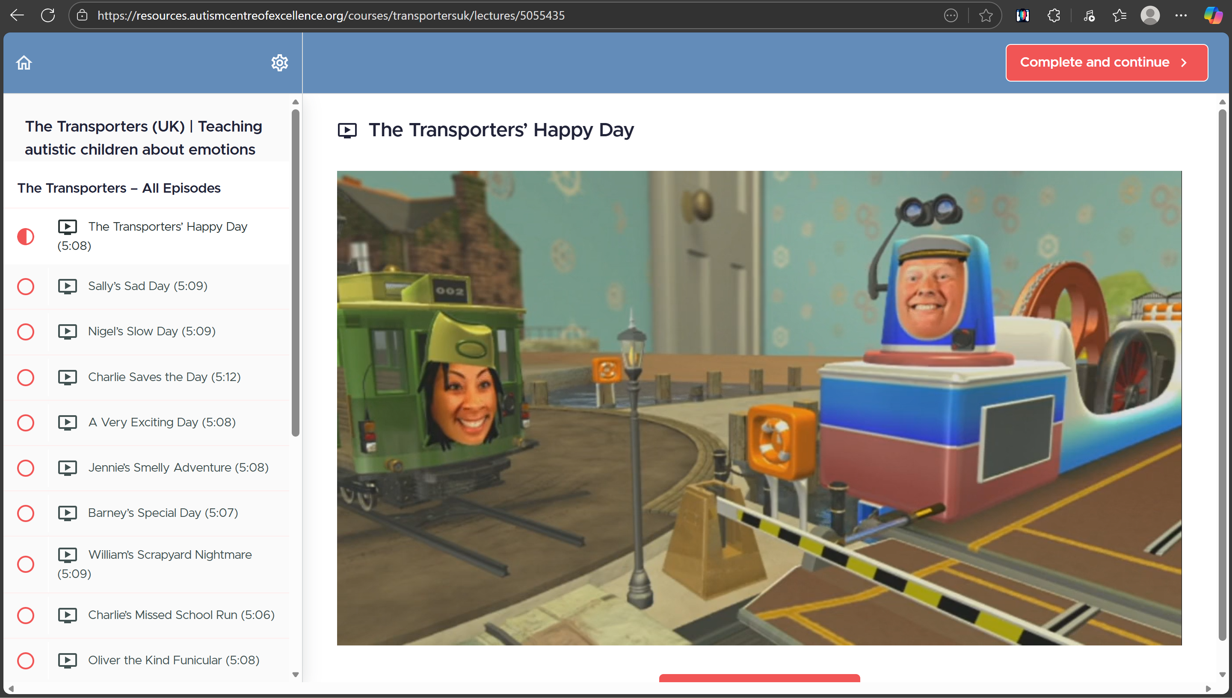

Figure 1 Example 1 on previous apps built for emotion recognition (Transporters)

* **MindReading**
  + MindReading is an electronic encyclopedia of human emotions designed to teach cognitive empathy (theory of mind) by presenting over 400 distinct emotions through video and audio clips [39]. Although it offers extensive content, the interface is information-dense and best suited for therapist-guided sessions rather than independent child use. The learning model emphasizes recognition over emotional expression [40].

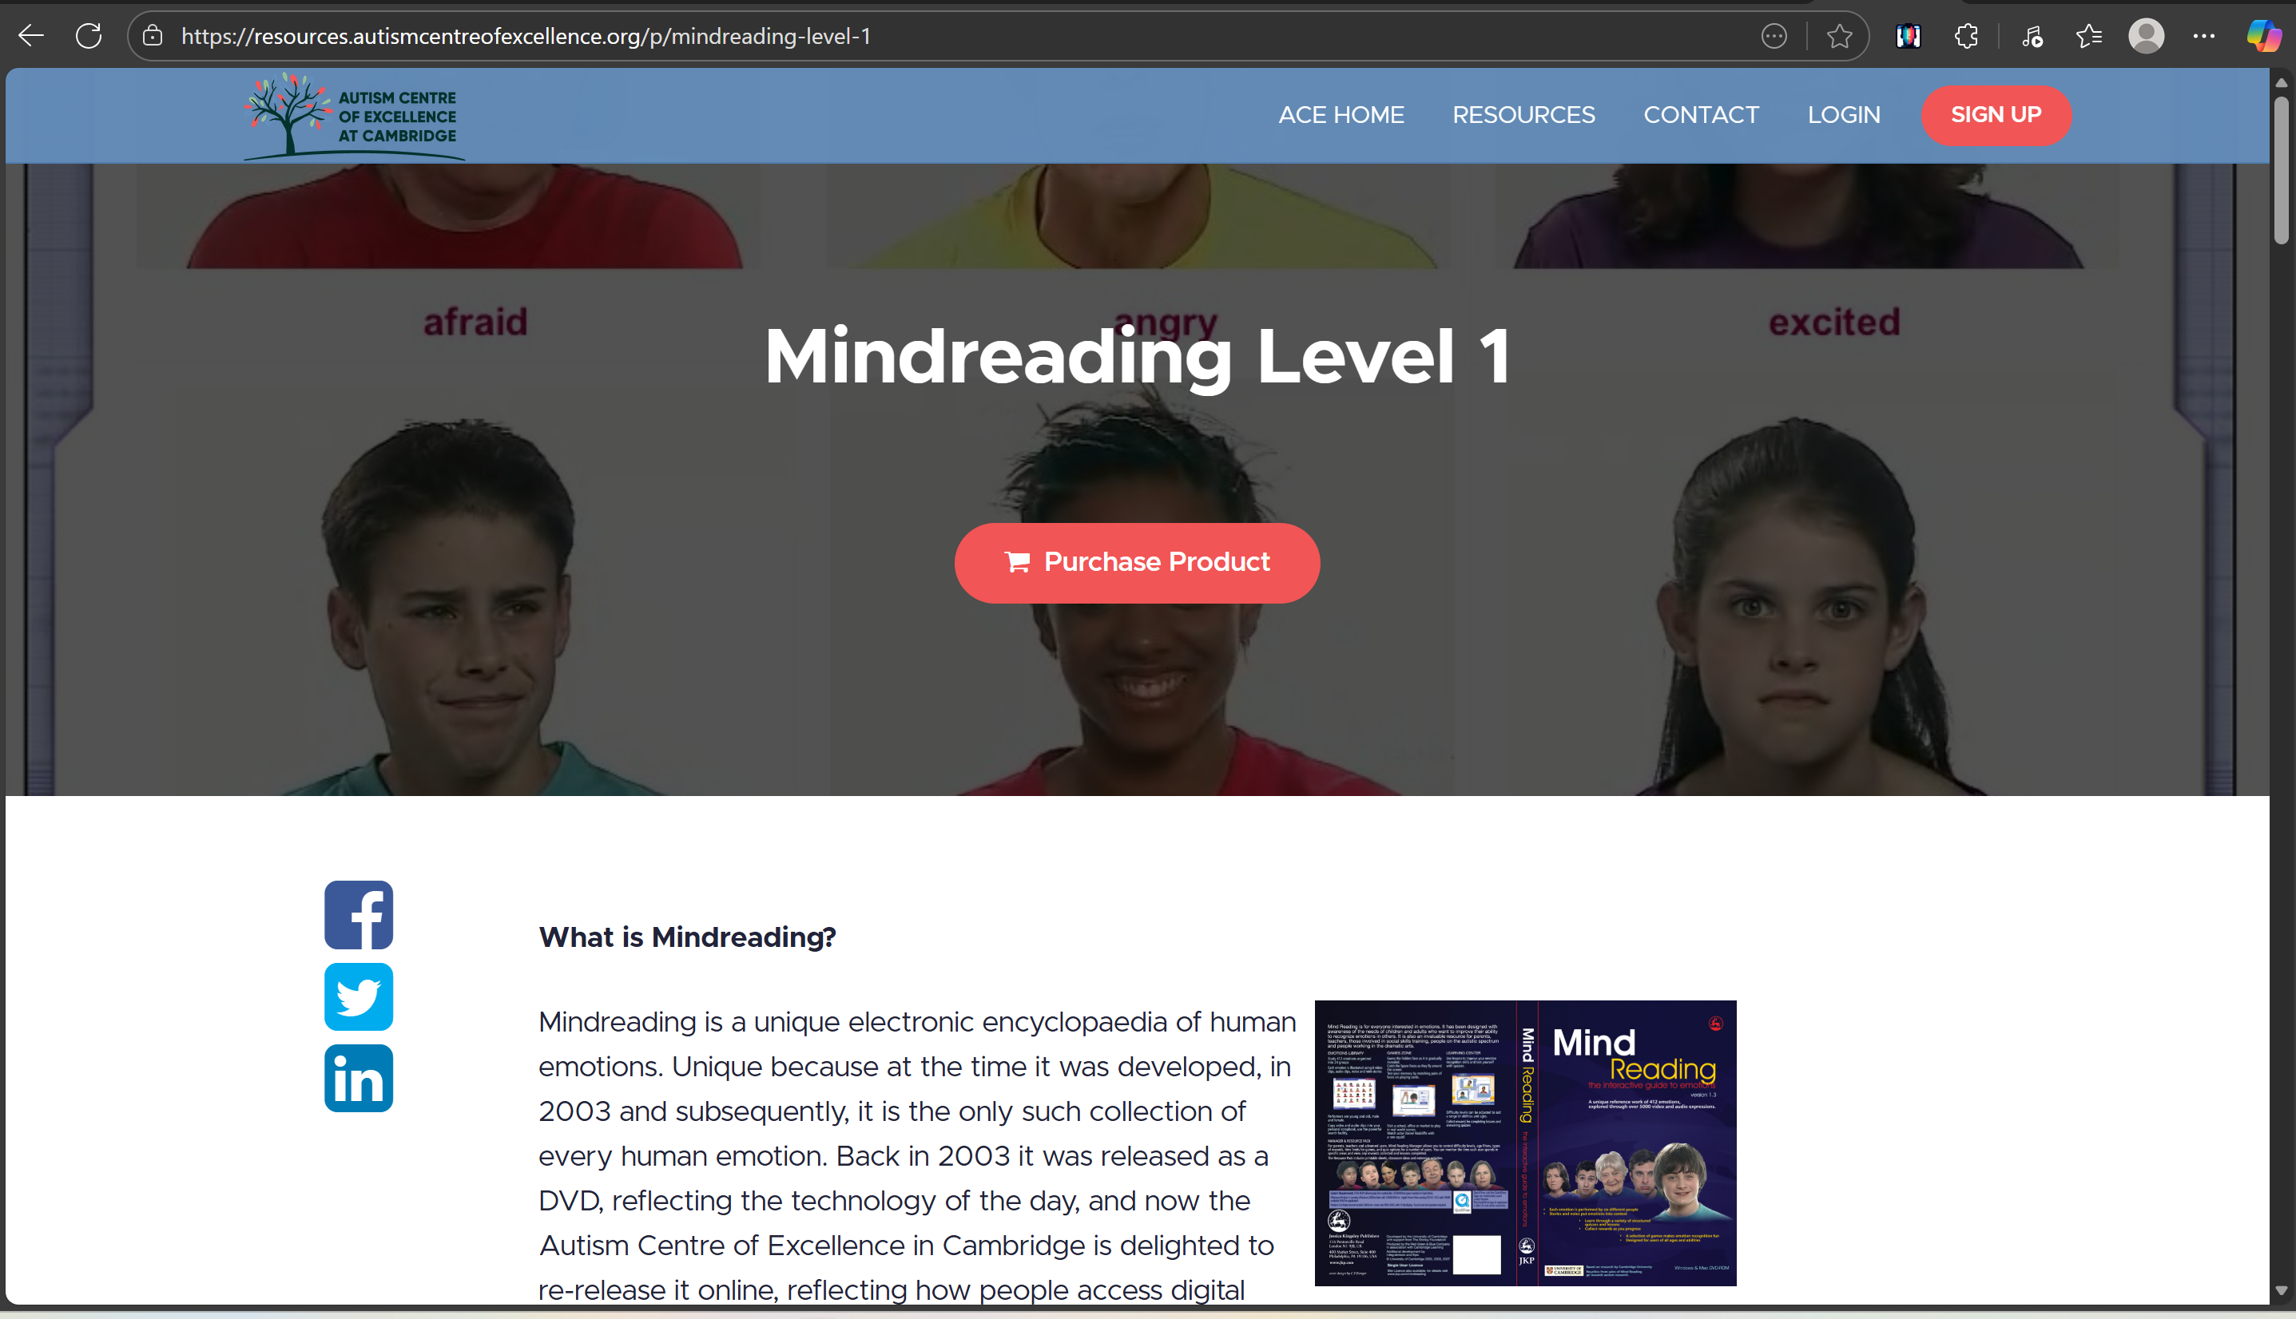

Figure 2 Example 2 on previous apps built for emotion recognition (MindReading)

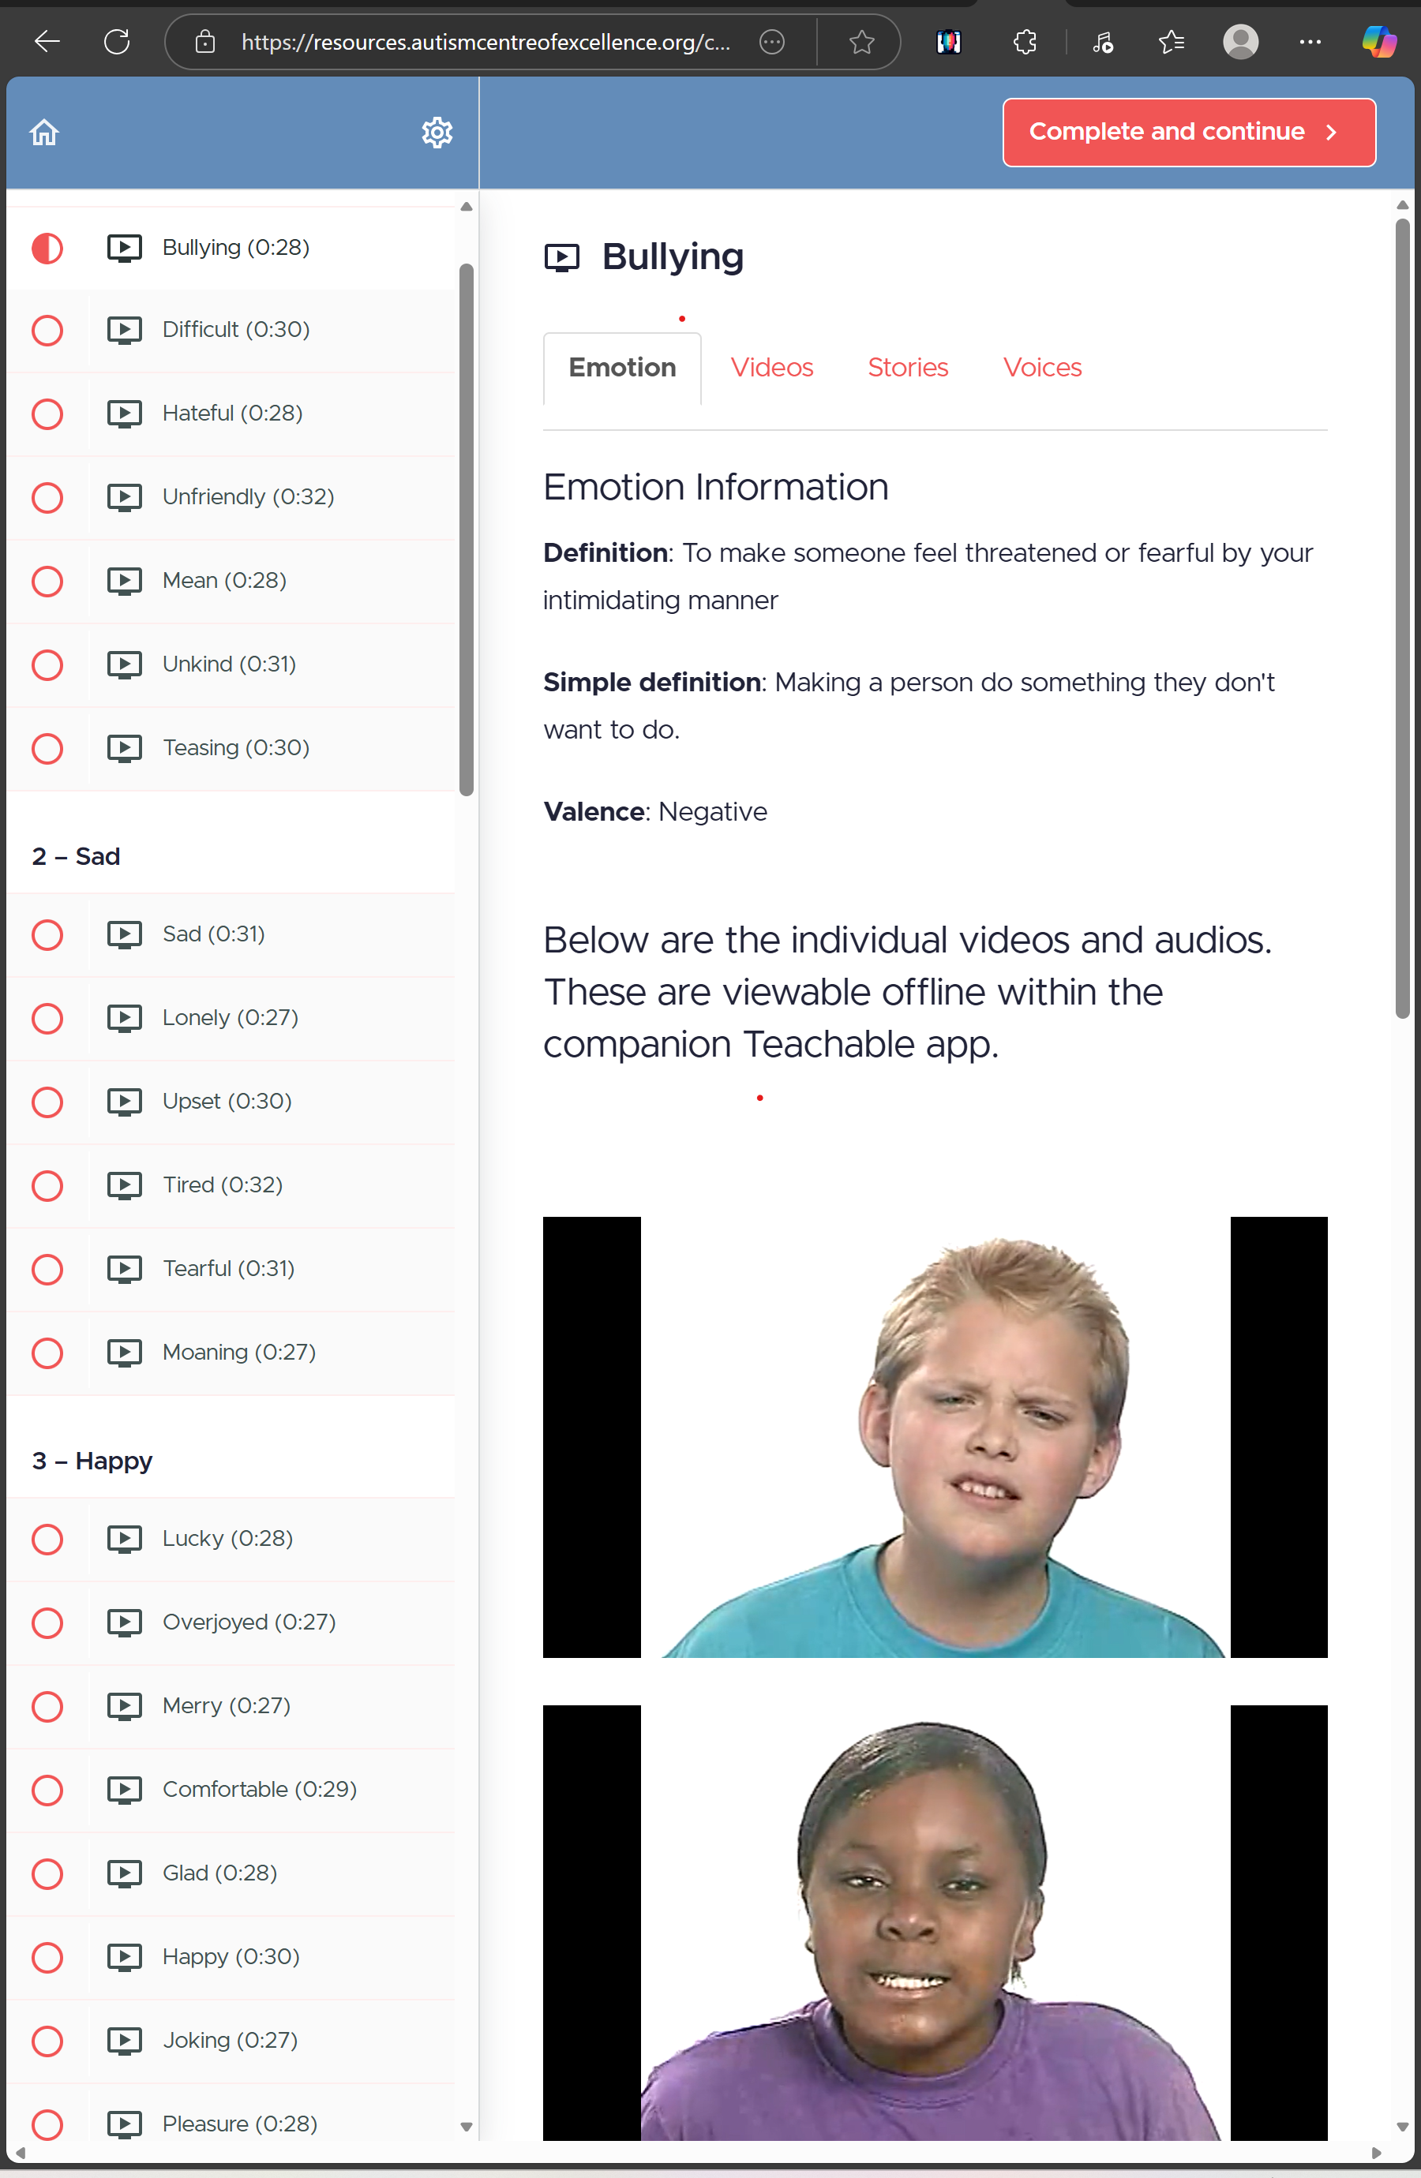

Figure 3 Example on previous apps built for emotion recognition (MindReading)

* **EmoFace**
  + EmoFace provides multiple training levels and customizable user settings [41]. However, its animated faces lack realism, which can be confusing even for neurotypical users. The absence of real-time interaction, limited feedback, and the need for guardian supervision restrict its potential for autonomous learning.

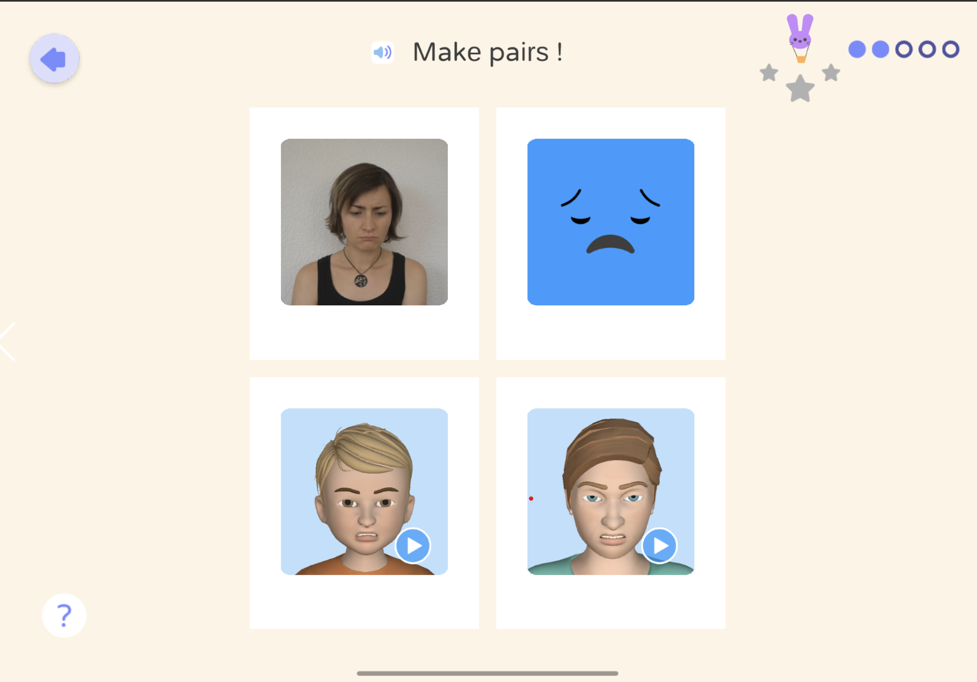

Figure 4 Example on previous apps built for emotion recognition (EmoFace)

* **AutismEmotions**
  + AutismEmotions offers simple, flashcard-style scenarios. For example, “this happened; how do I feel?”. However, it only includes four main emotions and no adaptive progression [42]. While easily accessible, its static structure offers little reinforcement or motivation, limiting its long-term educational impact.

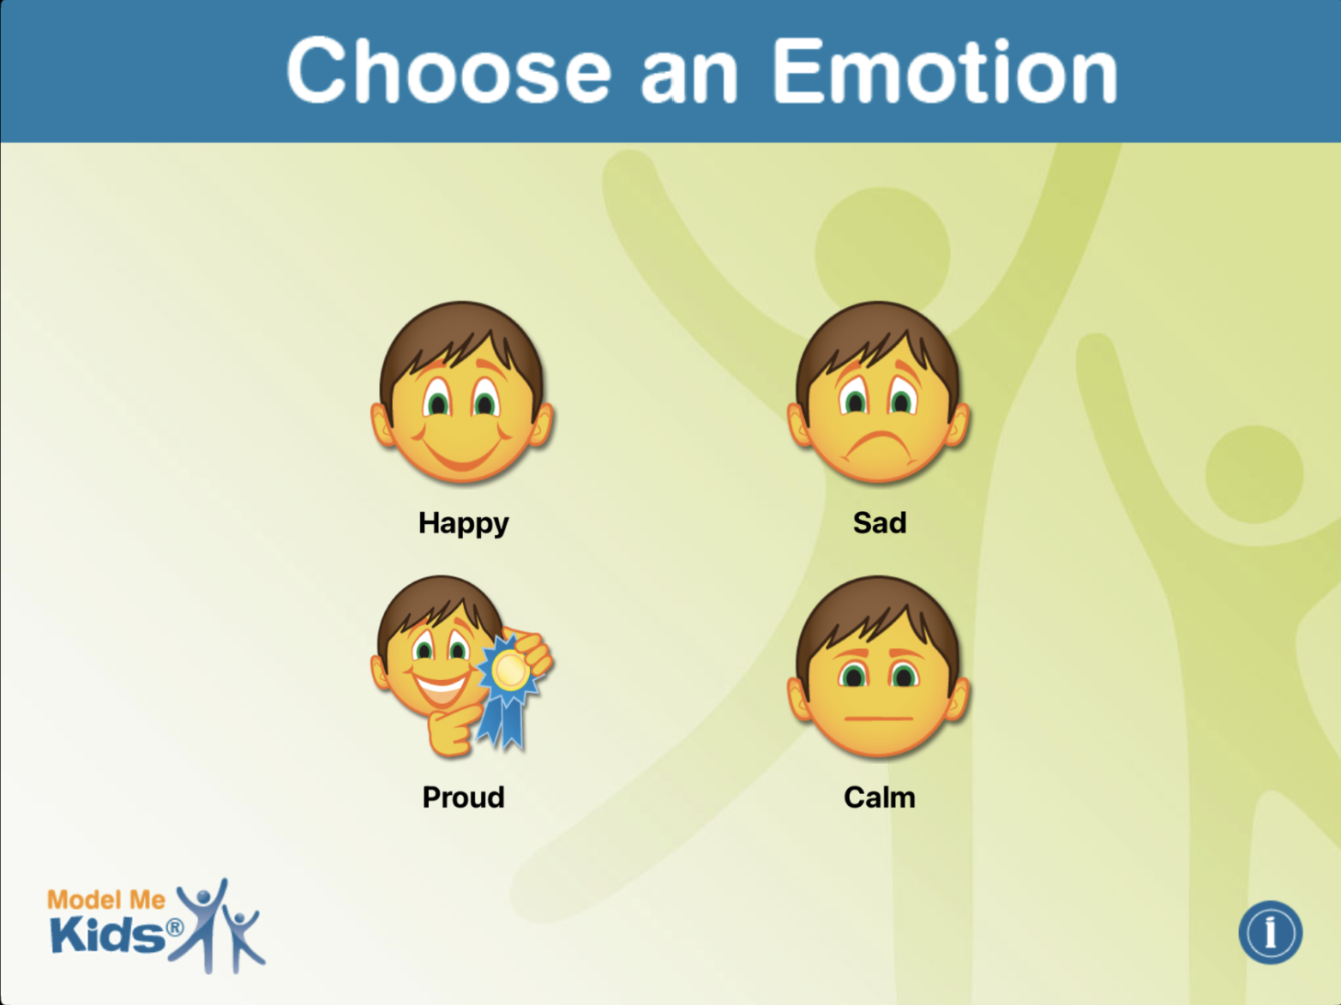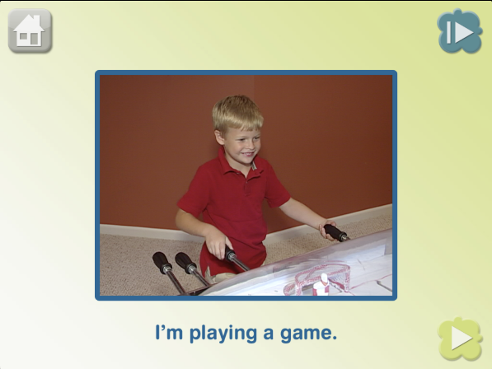

Figure 5 Example on previous apps built for emotion recognition (AutismEmotions)

Table 2 Comparison Between Feel-o and Previous Solutions

|  |  |  |  |  |  |
| --- | --- | --- | --- | --- | --- |
| Feature / Aspect | The Transporters | MindReading | EmoFace | Autism  Emotions | Feel-o |
| Type | Video series + quizzes | Multimedia encyclopedia | Interactive app | Flashcards | Gamified learning app |
| Interaction Style | Low (watch & answer) | Low | Moderate | Low | **High (playable levels, missions)** |
| Realism of faces | Human faces on toys | Real human videos | A mix of cartoon faces and human faces | Real static human pictures | **Realistic 3D avatars** |
| Progress Tracking | Limited | None | Minimal | None | **Comprehensive parent/teacher dashboard** |
| Adaptivity (verbal/non-verbal) | No | No | Partial | No | **Fully adaptive modes (voice, text, PECS)** |
| Independence | Requires supervision | Requires therapist | Sometimes guardian help | Guardian help | **Independent use encouraged** |
| Gamification & Rewards | Episode repetition | None | Basic progress levels | None | **Levels, missions, rewards, customization** |
| Emotion Scope | ~8 basic emotions | 412 emotions | Several basic ones | 4 emotions | **Progressive from basic to advanced emotions** |

Current solutions demonstrate that digital tools can facilitate emotional learning for children with ASD; however, they all show significant limitations in interactivity, adaptivity, and the capacity to generalize to real-world social contexts.

Our proposed system advances prior work by integrating gamification to deliver active, feedback-based learning instead of passive observation It supports both verbal and non-verbal communication modes, allows personalized settings to accommodate diverse needs, provides progress tracking and adaptive difficulty to foster engagement and independence, and employs repetition within minimalistic yet immersive environments to aid retention without sensory overload [45].

This results in a novel, user-centered platform that enhances emotional recognition, expression, and regulation among children with ASD while giving caregivers and educators actionable, data-driven insights.

# Requirements analysis

## Software development process

<**ToDo:**

Among the various possible software development processes introduced in your software engineering course, select and **justify** the most appropriate process that aligns with the specific requirements of your project.

/>

The Prototyping Model was adopted for the development of Feel-o. This model emphasizes the early creation of a simplified version of the system, known as a prototype, which is continuously refined through repeated evaluation and feedback until it evolves into the final product. Such an approach was deemed most suitable for Feel-o because its requirements and design specifications were expected to evolve throughout the development process as feedback is obtained from therapists and domain experts. As the project involves addressing the specific needs of children with ASD, the iterative feedback structure of the Prototyping Model ensures that the resulting system achieves both usability and effectiveness.

The Prototyping Model [46] supports multiple prototype types, including low-fidelity prototypes, such as sketches and wireframes, and high-fidelity prototypes, which more closely resemble the final application. In the early stages of development, low-fidelity prototypes enable rapid exploration of design alternatives and facilitate expert feedback with minimal resource investment. These prototypes are then progressively refined into higher-fidelity versions that incorporate interactive and visual elements representative of the final product. This gradual evolution from concept to functional system allows early validation and continuous improvement throughout the development of the game.

Although other development models were considered, they were found to be less suitable for Feel-o’s nature and goals. The Waterfall Model, for instance, was rejected because it follows a rigid, sequential structure that requires all requirements to be finalized before implementation begins. Such an approach would have limited flexibility and made it difficult to incorporate ongoing feedback from therapists and domain experts. The Agile Model was also considered, as it supports iteration and continuous stakeholder input. However, Agile frameworks like Scrum or Kanban depend on regular sprint cycles, daily meetings, and constant involvement from stakeholders. These practices work well in large professional teams but felt less practical in Feel-o’s case. Our development process involved occasional check-ins with therapists rather than continuous collaboration, so fully applying Agile wasn’t realistic. Still, some Agile ideas, such as iteration and regular feedback, were used informally to guide how the prototypes were improved over time.

## Applying the software development process

</**ToDo:**

* Describe and provide evidence on how you effectively **applied** the adopted Software Development Process throughout the project to produce the solution. This should also be reflected in the project plan presented in section ‎0.
* Utilize in-text citations to refer to relevant sections of the report, providing concrete evidence of the proper application of the chosen software development process. For instance, you can reference specific sections within the report that elaborate on the requirements gathering phase, design phase, testing procedures, or project management strategies.
* Discuss any related issues, challenges, difficulties, advantages or drawbacks, and lessons learnt during the software development process. For example, you can describe how the chosen methodology helped to address specific project challenges or how it fell short in some areas.
* This subsection is extremely important and required.

/>

The following describes the different phases of the Prototyping Model and how it has been and will continue being applied in the development of Feel-o:

**Requirement Gathering and Analysis**

The initial stage of the Prototyping Model involved defining the problem and outlining the objectives of the proposed system. The concept for Feel-o originated from the idea of supporting children with ASD in recognizing and expressing emotions in an interactive manner. At this stage, the exact user needs and domain-specific requirements were not yet clearly defined. To address this, as seen in Section 2.2, background research was conducted on existing solutions, specifically web and mobile applications, designed to enhance emotional recognition skills among children with ASD, with particular attention to their functionality, user engagement, and limitations. Research was also conducted on the target customers (children with ASD) to better understand their different way of perceiving the world.

Consultations were also held with two professional therapists who work closely with children with ASD to gain insights into the strategies used during therapy sessions and the potential role of technology in reinforcing these skills. Based on this research and expert feedback, it was determined that a game-based solution would be more effective and engaging than a structured educational application. This direction was chosen to encourage voluntary, self-guided participation rather than task-oriented use, thereby minimizing the feeling of obligation. Furthermore, the decision was made not to design Feel-o as an educational tool for classroom or therapy use, but rather as an activity that children can engage with during their personal screen time at home. This approach aims to make productive use of existing screen habits while avoiding additional exposure during therapy sessions.

**Quick Design and Prototype Development**

After completing the requirements analysis, the design of Feel-o was initiated based on the recommendations obtained from the initial consultation with the therapists. The process began with outlining the core game flow and defining the content and objectives of each level, including how emotions would be introduced and practiced. At this stage, the design was primarily conceptual, consisting of written descriptions supported by minimal sketches (such as those in Section 6.4) illustrating the layout, characters, and scenarios. These early representations served as low-fidelity prototypes, developed to communicate ideas quickly and facilitate expert feedback without significant resource investment.

Subsequent cycles of this stage were carried out after each feedback session, progressively enhancing the design clarity and alignment with the therapists’ guidance. By the end of the SDP1, parts of Feel-o have been implemented in Unity as a high-fidelity prototype, representing approximately 30% of the total system.

**User Evaluation and Feedback Loop**

Each prototype version of Feel-o was presented to the therapists for evaluation and professional feedback. During these review sessions, the therapists examined the game flow, level content, and other details in the design of the prototype. Their observations and feedback focused on coming up with design choices that would encourage children with ASD to play the game while still being effective in advancing their emotional skills. Feedback was also provided on reward mechanisms and reinforcement styles to confirm that the game supported emotional learning in a positive and non-pressuring manner.

Through multiple meetings held throughout the semester, the therapists’ input guided several important adjustments, including simplifying certain levels and reducing the number of emotional choices per level. Each feedback session functioned as a validation checkpoint within the iterative prototyping cycle, ensuring that the design decisions remained aligned with therapeutic best practices and the needs of children with ASD.

**Refinement and Iteration**

Following every evaluation, the design and partial implementation of Feel-o were refined to incorporate the recommendations received. The refinement process involved revising the visual elements and restructuring certain game interactions based on the therapists’ comments. These modifications were documented and implemented in successive prototype versions, which were then prepared for further review. Appendix C shows our very first initial deign of the game levels after a meeting with one of the therapists.

Additionally, regular weekly progress meetings held with Dr.Tamer ensured the team stayed on track and provided valuable feedback. In addition, separate team meetings were held between members to discuss progress, divide tasks, etc.

Through this continuous feedback and revision loop, the prototype evolved incrementally in both functionality and fidelity. By the end of SDP1, multiple feedback sessions had been completed, each contributing to an improved version of the prototype.

**Final Product Development**

The final product development phase will take place during SDP2 and will build upon the validated prototype developed in SDP1. Once the major components have been implemented, additional feedback loops will include direct testing with the target users (children with ASD) under professional supervision and ethical approval. These user sessions will focus on validating the game’s engagement, accessibility, and educational impact. By the conclusion of SDP2, Feel-o is expected to evolve into a fully playable and polished game that can be used independently by children with ASD during their personal screen time, offering an enjoyable and meaningful way to practice emotional recognition and expression.

**Challenges, Advantages, and Lessons Learnt**

Applying the Prototyping Model during the development of Feel-o proved highly beneficial as the project had evolving requirements. The iterative structure of the model enabled continuous improvement through frequent consultation with domain experts, allowing early detection and correction of design issues before significant resources were invested in implementation. The ability to visualize the system through low-fidelity and high-fidelity prototypes helped clarify the project’s direction in balancing educational and entertainment elements. This approach ensured that the game remained engaging while also adhering to therapeutic principles suitable for children with ASD.

Despite its advantages, the process presented several challenges. Translating clinical feedback into specific design or technical features required considerable interpretation and experimentation. Each feedback cycle demanded additional time and adjustments, which occasionally delayed implementation progress. Furthermore, as ethical considerations limited direct user testing, validation relied primarily on expert evaluation, leaving user-centered testing to future stages.

In summary, the use of the Prototyping Model enabled Feel-o to evolve through evidence-based decision-making and iterative improvement. The continuous engagement with experts ensured that the system design remained grounded in practical needs, resulting in a more purposeful product.

## Functional requirements

< **ToDo:**

* Gather, document, and analyze the project requirements.
* Present the requirement specifications using suitable methods and tools, such as a use case diagram and a use case summary table.
* Produce detailed specifications for each use case and add it to *Appendix A - Use cases specification*.
* You may use flowcharts to describe the sequence of actions and data flow of process(es) required for your project.
* After identifying and describing all the use cases, prioritize them and determine your project's scope by highlighting the use cases you intend to design and implement.

/>

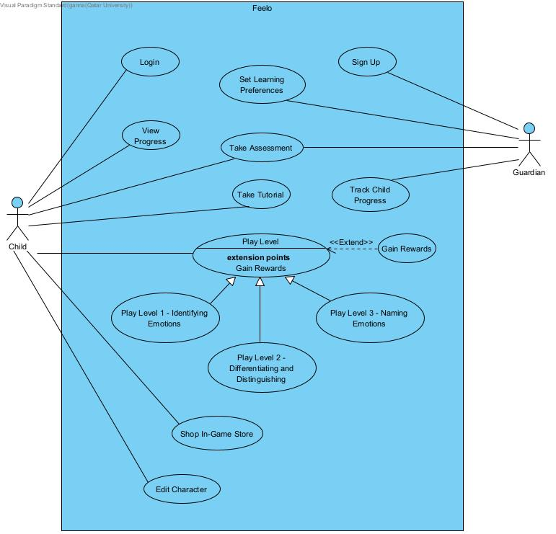

Figure 6 Use Case Diagram

Table 3. Use cases summary

|  |  |  |
| --- | --- | --- |
| ID | Use case | Brief description |
| UC01 | Sign Up | The guardian creates an account for the child. |
| UC02 | Set Learning Preferences | The guardian sets communication and learning preferences and enters a PIN for progress access. |
| UC03 | Take Assessment | The child is assessed on their skills before starting gameplay. |
| UC04 | Take Tutorial | The child is guided through an interactive walkthrough of game features and controls. |
| UC05 | Login | The user is authenticated to access Feel-o. |
| UC06 | Play Level 1 - Identifying Emotions | The child practices identifying emotions through three sublevels with repeated exposure to build memorization. |
| UC07 | Play Level 2 - Differentiating and Distinguishing | The child practices differentiating and distinguishing emotions through five sublevels. |
| UC08 | Play Level 3 - Naming the Emotions | The child practices naming emotions through three sublevels. |
| UC09 | Track Child Progress | The guardian views progress data including level performance and emotional skill development. |
| UC10 | View Progress | The child views game progress and earned rewards in a child-friendly format. |
| UC11 | Gain Rewards | When the child completes specific actions or levels, the system awards in-game rewards. |
| UC12 | Edit Character | The child customizes their avatar using items purchased with in-game rewards. |
| UC13 | Shop In-Game Store | The child spends in-game rewards to purchase items from the store. |

**Game Levels and Therapeutic Validation**

It is important to highlight that the structure and content of the game were developed in collaboration with and approved by licensed therapists prior to implementation. This step ensured that all game mechanics, objectives, and activities are therapeutically appropriate, engaging, and beneficial for children on the autism spectrum. The levels were carefully designed to progress gradually in difficulty and cognitive demand, supporting both verbal and non-verbal players according to their preferences.

Each level, referred to as a chapter, focuses on a distinct learning goal that contributes to the child’s emotional recognition and expression skills. Each chapter has its missions or exercises that must be completed to achieve the learning goals. These missions are referred to as quests. The following summarizes the game’s progression, explained using the terminology approved by the therapists to explain the goals of the levels and the game-terms used to attract the children:

**Login:**

* Sign up / Login
* Choose preferences when signing up
  + Verbal/ Non-Verbal
  + Read/ Write
* A reward system in the form of in-game currency is introduced at this stage to reinforce engagement and motivation.

**Level 0, aka Chapter 0 - The Beginning of the Journey**

* **Quest 0.1 – The Self-Discovery Test:** 
  + Test the children’s comprehension and receptive skills
  + The assessment should be auditory, visual and written
  + If the child fails the test, they are given an option to retake the test
* **Quest 0.2 – The First Steps:** 
  + This is simply a tutorial that explains to them how they can play the game

**Level 1 – Identifying the emotions, aka Chapter 1 - The Faces of Feeling**

* **Quest 1.1 – The Watchful Observer:** 
  + In this exercise, they see characters walking around the room with a small bubble next to them that shows the emotion; they are asked to re-write or re-pronounce the emotion. This way they will start memorizing them
* **Quest 1.2 – Meeting Emotions:** 
  + In this exercise they get approached by a character whose emotion is also displayed, and they must repeat the previous task again
  + the difference between these two exercises is that the kid is observing in one and interacting in the other
* **Quest 1.3 – The Table of Feelings:** 
  + The child approaches a table that has a familiar character on it (could be a parent); they have a seat and play a card game.
  + The game is similar to the idea of flashcards. They flip one card at a time, see a picture with an emotion on it along with its name, they are asked to again write or read out loud the emotion written

Note: at the end of this level, we expect the child to have memorized as many emotions as possible through repetition

**Level 2 – Differentiating and distinguishing between emotions, aka Chapter 2 - The Emotion Detective**

* **Quest 2.1 – Spot the Feeling:** 
  + In this exercise, the child interacts with characters who have different emotions and choose which emotion they see (in the form of multiple-choice questions)
* **Quest 2.2 – Match the Mood**:
  + The flash cards game. In this game, the child should match the correct emotion to the right picture
* **Quest 2.3 – The Room of Feelings:** 
  + In this game, the child must walk into a certain destination (ex. a room) and they must choose all the characters that represent a specific emotion
* **Quest 2.4 – The Deck of Emotions:** 
  + The flash cards game. In this game, the child should choose all the cards that match one specific emotion

Note: the difference between 2.3 and 2.4 is that one is done on cards while the other is done on characters

* **Quest 2.5 – The Emotion Hunt:** 
  + In this exercise, the child is given a mission to go over to a number of characters that represent a certain emotion and interact with them. (Ex. Talk to 3 happy people).

**Level 3 – Naming the emotion, aka Chapter 3 - The Voice of Emotion**

* **Quest 3.1 – Say What You See:** 
  + In this exercise, the child interacts with characters who have different emotions and say/type which emotion this is
* **Quest 3.2 – The Word Match Challenge:** 
  + The flash cards game. In this game, the child should say/type which emotion each card represents
* **Quest 3.3 – The Emotion Scene:** 
  + In this game, the child must walk into a certain destination (ex. a room) and they must say which emotion all characters collectively represent
* **Quest 3.4 – The Great Card Calling:** 
  + The flash cards game. In this game, the child should choose all the cards collectively represent.

**Notes:**

* The difference between level 2 and level 3 is that level 2 gives them choices that they pick the correct answer from. In level 3 the child must know the emotion on his/her own without the help of any written/ spoken choices
* The in-game currency is called “Feel-oos”, which is a play on the words Feel-o which is the name of the game, and money in Arabic (فلوس). This name was chosen to add a lighthearted pun that creates a warm, fun, and culturally relatable tone for children.

Throughout these stages, repetition is intentionally used as a reinforcement method, as recommended by therapists. The design also accounts for different communication styles, allowing verbal and non-verbal children to participate equally, through writing, speaking, or choosing from visual aids such as PECS (Picture Exchange Communication System).

Additionally, therapists emphasized introducing real-life scenarios to help children generalize emotional understanding. Examples include common emotions like happiness, sadness, anger, fear, and surprise in early levels, progressing to more complex states such as boredom, discomfort (due to temperature), hunger, and thirst in later ones. These scenarios incorporate both facial and body language cues, encouraging a comprehensive approach to emotional literacy.

By adhering to these principles, our team ensured that the game’s design remains educational, inclusive, and therapeutic. We have consistently kept this framework in mind throughout the report’s development to reflect both clinical accuracy and empathetic design.

## Non-functional requirements

<**ToDo:**

* Identify non-functional requirements (i.e., desired quality attributes) and clearly document them using measurable scenarios, such that you can later test whether they are met (see Section *‎8. Testing and evaluation*).
* Categorize the requirements into different categories such as performance, reliability, security, usability, portability, and maintainability.
* Define precise, measurable targets for each requirement to facilitate future evaluation of their achievement during the testing phase. For instance, when addressing a performance requirement, it is crucial to define explicit metrics, such as maximum response time or throughput. Rather than merely stating a vague aim of ‘fast system’, provide specific measurable target like ‘Registering a new user should complete in under 10 seconds’. Likewise, regarding security requirements, avoid generic statements and specify the types of attacks the system must safeguard against and the threats it must withstand.
* Keep in mind: A non-functional requirement must be specific and measurable to be considered effective and valid.
* Include an evaluation plan for each non-functional requirement to test whether the system is meeting the specified targets. Include details of specific scenarios, tools or methods for evaluating each non-functional requirement.

/>

Table 4. Evaluation plan for the non-functional requirement

|  |  |  |
| --- | --- | --- |
| Non-functional requirement | Measurable targets | Evaluation Plan |
| Performance | Load within 5 seconds on typical mobile devices, including Unity asset initialization and Firebase connection. Maintain a minimum of 30 FPS during normal gameplay to ensure smooth interaction feedback. | Measure startup and Firebase data loading using Firebase Performance Monitoring. Measure rendering and frame rate using Unity Profiler. |
| Availability | Firebase Authentication and Database should maintain at least 99 % uptime. In case of connection failure, must display a clear “connection unavailable” message and allow the user to retry. | Monitor Firebase global uptime via Firebase Status Dashboard and track login success/failure events in Firebase Analytics to evaluate real-world availability. |
| Usability | (**therapist will be asked about this in next meeting(soon), will decide then) | Conduct usability testing sessions with a small sample of children along with therapists). Gather feedback through short therapist questionnaires. |
| Security | All user data must be transmitted and stored securely using Firebase Auth and Firestore. Access to data should follow Firebase security rules that restrict each user to their own records. | Verify that Firebase Authentication and Firestore security rules are correctly configured. |
| Portability | The game should run consistently on both Android and iPadOS devices. | Test the game on multiple devices. Verify no critical layout errors occur. |
| Accessibility | The game must accommodate different communication abilities by offering multiple input and feedback modes. Guardians should be able to set preferences for this. | Conduct accessibility testing with therapists or educators to confirm children can understand and interact with the game appropriately. |
| Privacy | No personally identifiable information (PII) about the child is shared without guardian consent. | Review Firebase Security Rules and data schema for compliance. |

## Assumptions

<**ToDo:**

* List any project-specific assumptions. These are statements or conditions that are believed to be true or expected to occur during the course of a project but are not guaranteed. They can become potential failure points that need to be monitored and managed.

For instance, in the case of a QU Indoor Navigation app project, one assumption could be the ability of obtaining AutoCAD floor plans for several buildings from QU Facilities Department.

* A bulleted list should be used for this section.

/>

The following assumptions were identified during the development of Feel-o. These assumptions represent conditions that are expected to remain true throughout the project lifecycle but are not guaranteed, and their validity may affect the project’s progress or outcomes.

* The therapists consulted throughout the development of the project will remain available for collaboration throughout future development stages.
* Institutional approval or ethical clearance will be granted for conducting user testing with children with ASD when required in later stages. (forgot the name of the document, will add later)
* Users will have access to a stable internet connection to enable cloud-based features such as authentication and data storage.
* The therapists’ feedback accurately reflects the needs and behaviors of children with ASD and can be used as a valid reference for game design decisions.
* The project scope and requirements will remain stable, with no major external changes imposed by course constraints or ethical restrictions.

## Ethics

<**ToDo:**

* Identify and discuss the legal and ethical considerations and professional responsibilities relevant to your project while taking into account the perspectives of stakeholders such as clients, users, team members, and the community impacted by the project. These ethical aspects can vary widely depending on the nature of the project, such as responsible management of confidential data, data privacy, security, accessibility, respecting intellectual property rights and avoiding plagiarism, and many other pertinent considerations.
* Define project-specific code of ethics by drawing upon relevant resources such as the [ACM and the IEEE Software Engineering Code of Ethics and Professional Practice](https://ethics.acm.org/code-of-ethics/software-engineering-code/)
  + Select the most relevant codes of ethics to effectively address the identified ethical considerations and professional responsibilities throughout the project's lifecycle. Your choices should align with the scope, objectives, and unique challenges of your project.

Do not copy and paste the entire ACM and IEEE codes of ethics into your report. Instead, review them and, in your report, concentrate on discussing those codes that are most applicable to your particular project.

* + Detail how you plan to incorporate and adhere to the selected codes of ethics at various stages of the project’s lifecycle.
  + Demonstrate your critical thinking by considering alternative courses of action and providing well-justified choices based on logical and persuasive reasoning.
  + Conclude your discussions with a table that summarizes the ethical considerations and professional responsibilities relevant to your project.

/>

The development of Feel-o adheres to the ACM/IEEE Software Engineering Code of Ethics and Professional Practice (Version 5.2) [47], which outlines the professional and ethical responsibilities of software engineers. Given the nature of this project, several principles from this code were identified as particularly relevant. The following list highlights the most applicable clauses that guided ethical decision-making throughout the project’s lifecycle.

*1.01. Accept full responsibility for their own work.*

*1.03. Approve software only if they have a well-founded belief that it is safe, meets specifications, passes appropriate tests, and does not diminish quality of life, diminish privacy or harm the environment. The ultimate effect of the work should be to the public good.*

*1.07. Consider issues of physical disabilities, allocation of resources, economic disadvantage and other factors that can diminish access to the benefits of software.*

*1.08. Be encouraged to volunteer professional skills to good causes and contribute to public education concerning the discipline.*

*2.01. Provide service in their areas of competence, being honest and forthright about any limitations of their experience and education.*

*2.05. Keep private any confidential information gained in their professional work, where such confidentiality is consistent with the public interest and consistent with the law.*

*3.04. Ensure that they are qualified for any project on which they work or propose to work by an appropriate combination of education and training, and experience.*

*3.07. Strive to fully understand the specifications for software on which they work.*

*3.12. Work to develop software and related documents that respect the privacy of those who will be affected by that software.*

*7.02. Assist colleagues in professional development.*

*7.03. Credit fully the work of others and refrain from taking undue credit.*

*7.05. Give a fair hearing to the opinions, concerns, or complaints of a colleague.*

*7.08. In situations outside of their own areas of competence, call upon the opinions of other professionals who have competence in that area.*

Table 5. Project-specific code of ethics and professional responsibilities

|  |  |
| --- | --- |
| Ethical consideration / professional responsibility | How to address it throughout the project's lifecycle |
| 1.01 | All team members assume full responsibility for their assigned tasks, ensuring reliability and accountability in every phase of development. |
| 1.03 | Feel-o is developed and tested to ensure it is safe, appropriate for children, and beneficial for its target users (children with ASD). Feedback from therapists helps validate that it supports emotional learning to improve quality of life. |
| 1.07 | Accessibility and inclusivity are considered in all design choices. Visual elements, interaction methods, and prompts are developed to accommodate varying communication and cognitive abilities among children with ASD. |
| 1.08 | Feel-o contributes to social good by creating a supportive tool for children with ASD. It also raises awareness about emotional learning challenges and the role of technology in supporting them. |
| 2.01 & 7.08 | The team works within its technical expertise while consulting therapists and domain specialists to ensure that game content is appropriate and informed by real-world therapeutic practices, to allow it to be effective and beneficial. |
| 2.05 & 3.12 | Confidential user information is handled responsibly and never shared outside the project. |
| 3.04 & 3.07 | Team members maintain professional competence through research and continuous learning about ASD-friendly design and Unity game development. |
| 7.02 | Collaboration and knowledge sharing are encouraged among team members throughout Feel-os’s development. |
| 7.03 | Proper credit is given for all external assets, references, and research materials used in the project. The team follows academic integrity guidelines and respects intellectual property rights. |
| 7.05 | Open communication and respect are maintained during meetings and discussions. Differing opinions are addressed constructively to ensure decisions serve the project’s goals. |

# Project Plan

## 4.1. Project milestones

< **ToDo:**

* Create a table that outline and describe the project key milestones. For example, a milestone could involve choosing a use case (or a component from your high-level design) then designing, implementing, and testing its realization.

/>

In this section, our project planning in the course of the two-semester timeline we are given will be briefly described and laid out in different milestones. Each milestone, shown in Table 6 below, highlights the key phases of our project and their corresponding deliverables. Moreover, further decomposition of each milestone is shown in section 4.2. along with deliverables and assignments for each task.

Table 6. Project milestones

|  |  |  |  |  |
| --- | --- | --- | --- | --- |
| Id | Milestone | Description | Deliverables | Duration (Days) |
| 1 | **Project Initialization** | Research and propose project ideas that address significant problems. | Top 3 viable ideas per member along with background, description and its impacts | 7 |
| 2 | **Literature Review and Project Definition** | Solidify concept and knowledge on the idea by reaching out to autism experts and through literature sources. Define the problem statement, potential contributions and aims clearly | Clear documented concept, implications and depth of the problem. Problem statement, potential contributions and aims relevant to the project idea. | 14 |
| 4 | **Competitor & Existing Solution Analysis** | Identify and compare similar solutions to the idea that already exist in the market. | Documented existing solutions and their pros and cons in tabular form. | 7 |
| 5 | **Market research & Business Planning** | Perform market research to identify market needs, size, target customers, and business plan. | Documented information about the game market, target customer and over business plan. | 7 |
| 6 | **System Requirements Definition** | Define the system’s use case diagrams, specifications, functional and non-functional requirements. | Use-case diagram and specification, functional and non-functional system requirements | 14 |
| 7 | **System Architectural Design** | Design system architecture and database. Design the UML Class Diagrams, Activity Diagrams and UI drafting. | High-level system architecture diagram and a logical data model of the intended database. Including class diagram, activity diagram, and sketch of the envisioned UI navigation within the game. | 14 |
| 8 | **Initial Prototype Implementation** | Begin implementation and database setup. Build a quick prototype to target the uncertain/high-risk areas (movement feel, camera, level-flow). | Functioning educational game for Demo (version 1) to show core functionalities of the Game. | 36 |
| 9 | **User/Client Evaluation & Feedback** | User evaluation & feedback on initial prototype (version 1) | Observation notes, feedback summary and log snapshots of bugs. | 7 |
| 10 | **Prototype Implementation Loop** | Refine the prototype versions until polished (loop). Add visual (assets) improvements and address any issues. | Improved UI/UX, asset composition and gameplay. | 84 |
| 11 | **Final Testing & Feedback** | Perform debugging, test core functionality of the system by conducting play-mode test, edit-mode test and performance testing. Continue with Implementation to polish. | Suitable test results for the game and a polished debugged product for final presentation | 9 |

## 4.2. Project timeline

< **ToDo:**

* The project timeline defines **who** will do **what** and **when** to ensure efficient project execution and progress tracking. You need to:
* Develop a detailed project timeline that breaks down each milestone into smaller, manageable tasks.
* Estimate the time required to complete each task.
* Assign the tasks to individual team members and define a work schedule stating the start and end date of each task. You can use Microsoft Project or Excel to create your project timeline. Insert a [Gantt chart](https://en.wikipedia.org/wiki/Gantt_chart) and a project timeline table in this section.

Additionally, keep in mind the overall project duration, which typically spans around 14 weeks for each semester. It is vital to decide the roles and responsibilities of each team member to avoid any ambiguity.

* Be sure to include time to document your work at each milestone to incrementally produce your final report. Additionally, schedule time for project evaluation, reflection on the experience gained, and the finalization and review of both the report and presentation.

/>

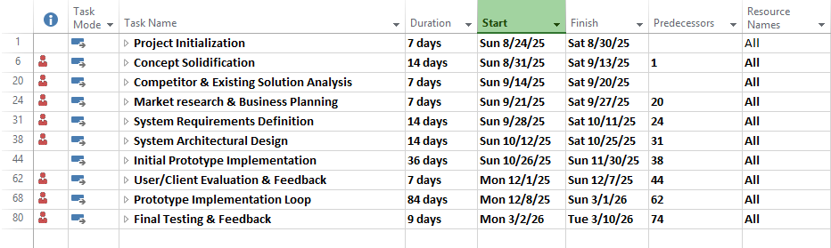

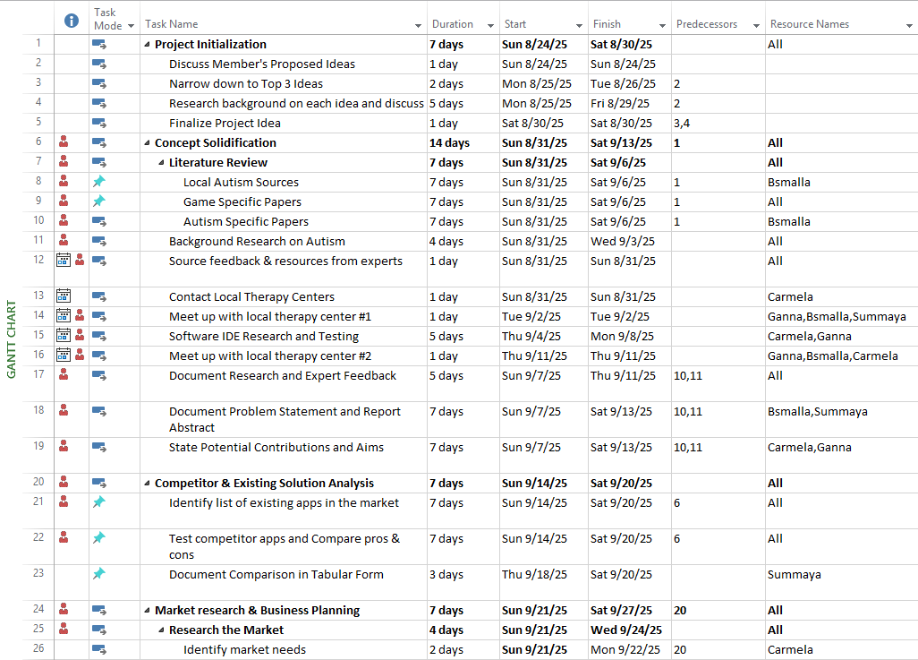

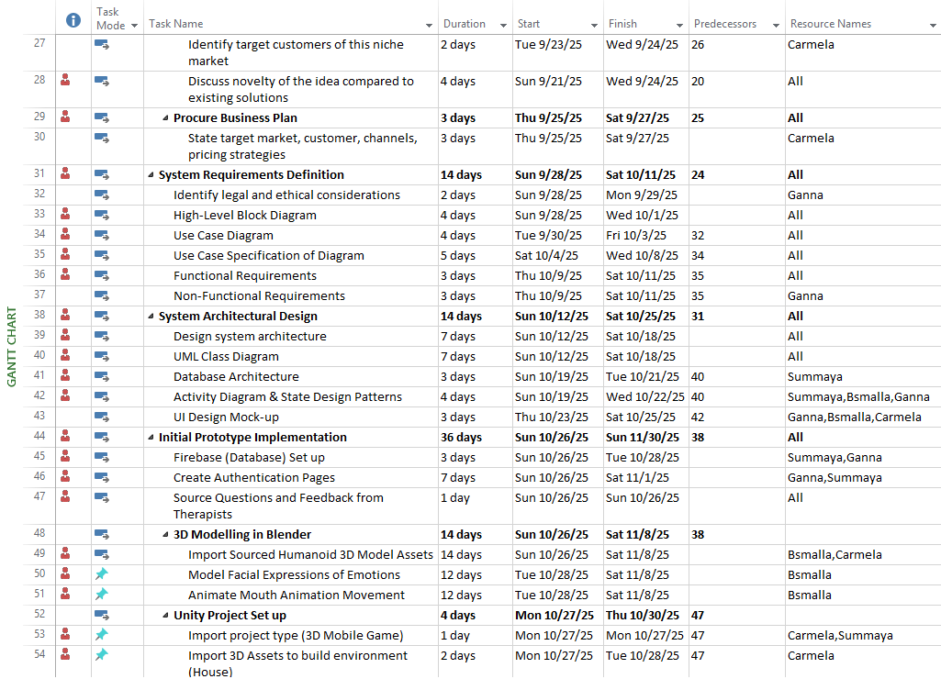

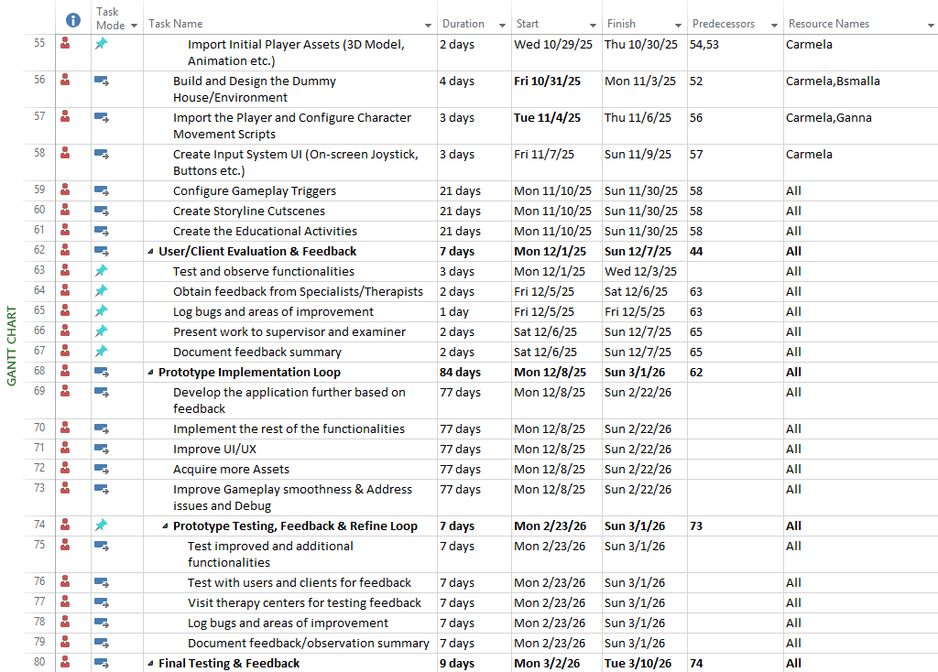

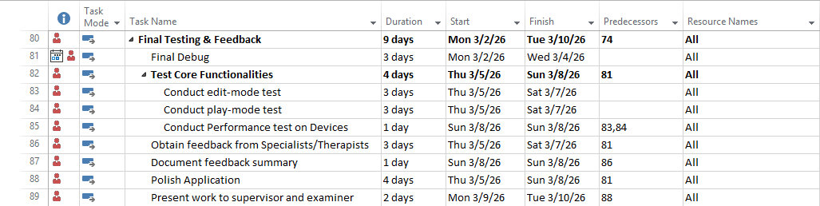

Figure 7 Project Timeline

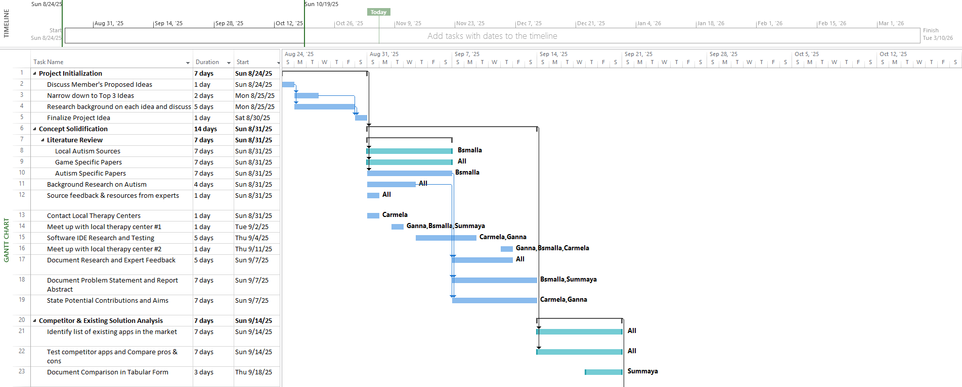

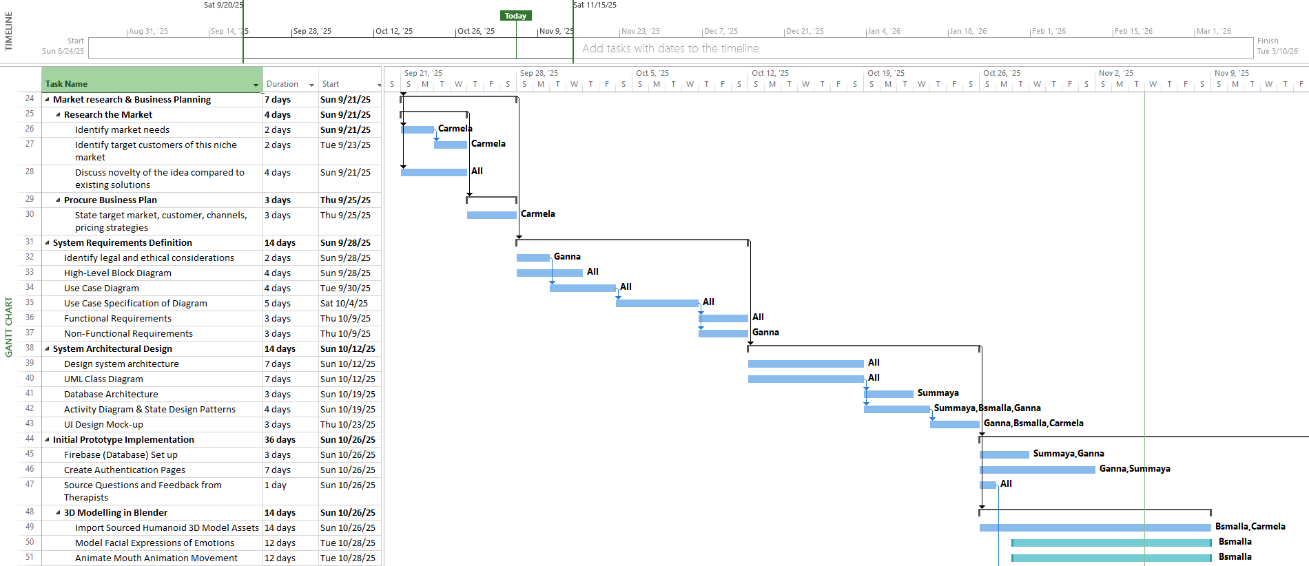

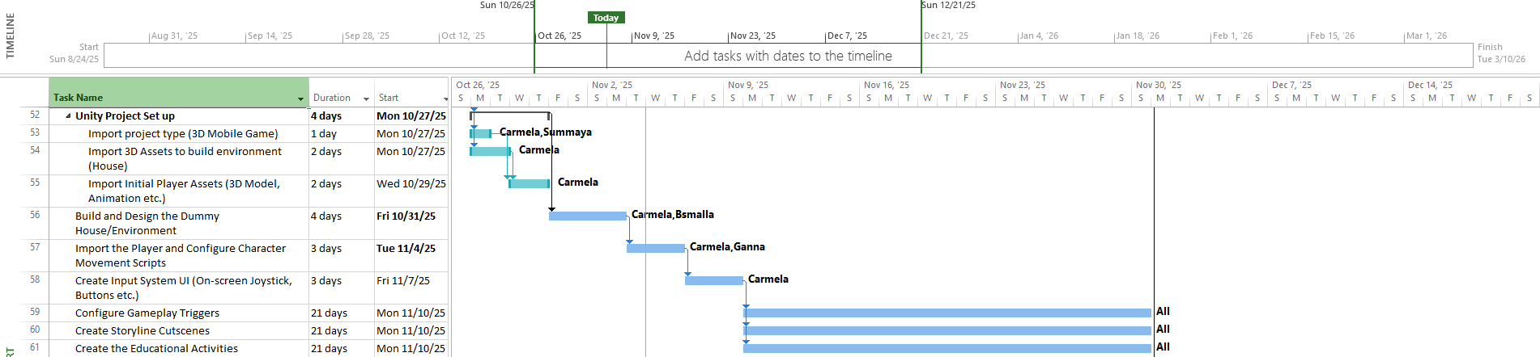

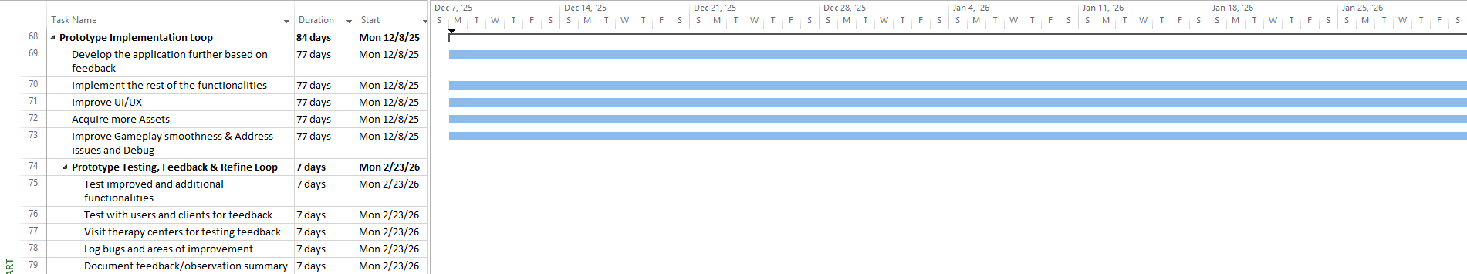

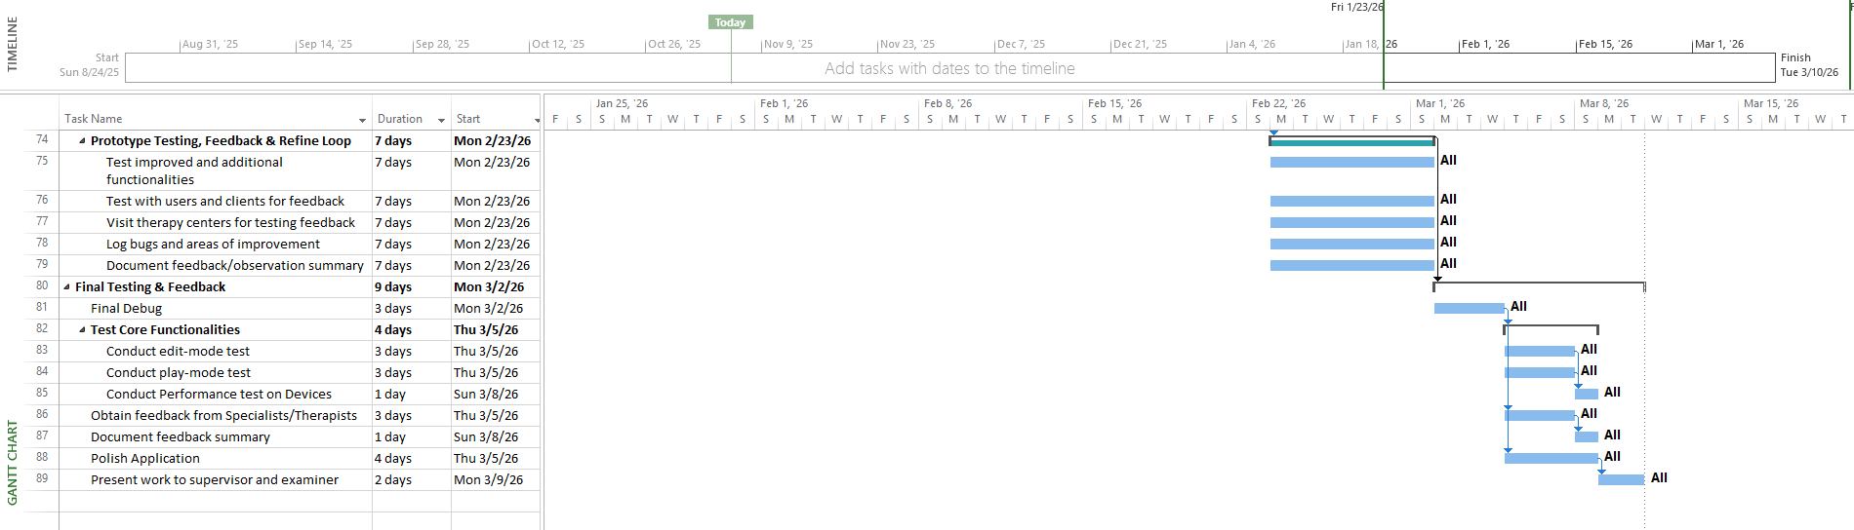

Figure 8 Project Gantt Chart: Timeline of key tasks and Milestones

## 4.3. Anticipated risks

< **ToDo:**

* Present a table that outlines potential risks, which are events that could jeopardize the successful completion of the project.
* Outline the approach to mitigate each identified risk, ensuring the project's smooth progression and minimizing disruptions.

/>

Table 8. Project Risks

|  |  |
| --- | --- |
| Risk | Approach to mitigate the risk |
| Delay in therapist/expert feedback | Reschedule and approach two therapists so at least 1 can meet up and work in parallel with other tasks that does not require their advice. |
| Loss of user data | Schedule backups and use a secure cloud storage like Firebase that ensures recovery and secure protection. |
| Children may struggle to grasp and use the UI intuitively | Run usability tests 3–5 target users in the prototype evaluation to gather feedback on interface usability to know what to apply in the final app. |
| Children may find some areas of the gameplay over-stimulating | Run usability tests 3–5 target users on the prototype to know which areas can be triggering and remove or tone-down effects (transitions, animation, lower volume). Implement a break after continuous playtime (Ex. 2hr play), game should suggest the child to stop, and end their level. |
| Asset licensing issues with third-party assets | Replace out-sourced assets and rebuild scenes. |
| Unity packages update may break the project build during collaboration | Ensure all the latest updates have been pushed to GitHub and collectively update each team member’s Unity software making sure everyone us working on the same versions. |
| Failing to complete the project on time | Use a GitHub Kanban to break down milestones into smaller tasks with clear due dates, lock an MVP scope, and hold weekly check-ins to monitor task completion and group burnout to adjust accordingly. |
| Child’s Gameplay progress is not saved after accidental game closing | Implement auto-save in intervals of 5 mins whilst having the option to manually save progress through the menu button. |
| Miscommunication between team members | To keep to everyone on the same page, conduct weekly check-ins, employ peer reviews on each other’s parts, and monitor work on GitHub Kanban. |
| Failure to get IRB in time to evaluate testing with children | Prepare and submit IRB document after first prototype is complete to have it approved by end of SDP 2. Then use proxies for in-between-project testing until it is approved (Ex. Test with adults/therapists) |
| Rejection and Delays in App Store & Play Store Deployment | Know store policies and follow Apple/Google submission checklists. |
| Performance on low-end tablets | With each prototype, test on one low-end tablet. Turn on low quality in unity itself, reduce particles, texture sizes etc. See what graphical situations it cannot handle and simplify it (less assets, not overload the system environment etc.) |
| Low user retention and engagement | Development of the game should continue to create more levels and increase different scenarios for each levels so that gameplay is repetitive as needed yet entertainingly varies. |

# System Architecture

## High level system architecture

< **ToDo:**

* Present a brief overview of the solution and the system's architecture, allowing stakeholders to understand its key components and interactions.
* Include a high-level system architecture diagram of the proposed solution that serves as a visual guide for the detailed design. The diagram should show how your solution is decomposed and organized into components. Use labeled boxes to represent components and arrows to show how they interact. Indicate external systems or services that the system may interface with.
* Describe the key responsibilities and functions of each component of your high-level architecture. Explain the interfaces they expose or utilize.
* Discuss the key interactions between the identified components, encompassing aspects like data flow, communication protocols, and dependencies between components. Use diagrams, flowcharts, or textual descriptions to clarify these interactions.
* Discuss the architectural style (e.g., Layered, MVC, SPA) used by your solution. Justify the choice of this architectural style, clarifying how it aligns with the project's requirements.

/>

A component-based architecture style was selected for the development of the emotional learning game. This approach aligns with Unity’s built-in component-oriented framework, where every game object in the scene is composed of modular components responsible for specific behaviors.

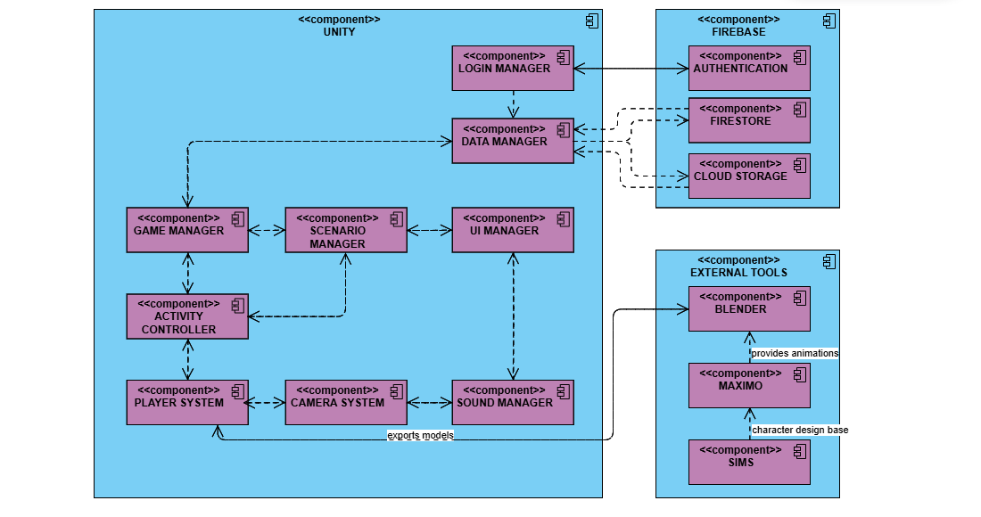

Figure 9 High-Level Component-based Architecture

The component-based style was chosen for several reasons:

* It promotes modularity, allowing each part of the system (such as UI, audio, or scenario logic) to be developed, tested, and maintained independently.
* It enhances reusability, as the same component can be attached to different objects or reused across multiple scenes
* It supports flexibility and scalability, enabling future additions such as new scenarios or activities without major architectural changes.
* It follows Unity’s natural design philosophy, reducing complexity and ensuring smoother integration with Unity’s built-in systems like physics, animation, and scripting.

Additionally, the game follows a client–server model, where Unity acts as the client handling game logic and interface, while Firebase serves as the backend, managing authentication and cloud data storage. This dual-structured architecture ensures that user data and progress are securely stored and can be accessed across devices.

The different components of the game's system architecture are explained as follows:

* Login Manager: Acts as the middle layer between Unity and Firebase SDK. Uses Firebase APIs for Authentication.
* Data manager: Acts as the middle layer between Unity and Firebase SDK. Uses Firebase APIs for Firestore, and Cloud Storage.
* UI manager: Manages all visual and interactive UI (menus, quests, buttons, virtual joystick), as well as listens to player input events and invokes Game Manager
* Sound Manager: Handles sound effects and background music events.
* Scenario manager: Implements the mission/level logic. Handles streak counting, activity sequencing, and reward progression.
* Camera manager: Controls cinematic transitions and third-person camera tracking through Cinemachine.
* Game: Manager: Coordinates all systems; initializes gameplay, monitors player progress, and communicates with Data Manager.
* Activity controller: Dynamically spawn and manage different activity types based on config data. Internally calls the Scenario Manager for success/failure tracking.
* Player system: Handles movement, animations, triggers, and cutscenes, and receives input from the UI manager.
* Authentication: Identifies users and maintains their session (email/password or anonymous).
* Firestore: Stores user progress (levels, streaks, timestamps).
* Cloud storage: Holds media and voice-over assets.
* External tools: Serve as asset creators, not runtime components. Models and animations are exported into Unity during the development phase.

The overall interaction between Unity and Firebase follows a **client–server workflow**:

* The player logs in via the Unity interface. The Login Manager sends the credentials to Firebase Authentication for verification.
* Once authenticated, the Game Manager requests player progress data from the Data Manager, which in turn retrieves it from Firebase Firestore.
* During gameplay, the Scenario Manager controls the flow of emotional scenarios, delegating specific tasks and activities to the Activity Controller.
* As the player completes activities, results are reported back to the Game Manager, which may update the UI and trigger sound or animation responses.
* The Data Manager periodically saves the updated progress to Firebase Firestore to ensure continuity across devices.
* Throughout the session, the UI Manager and Sound Manager respond dynamically to in-game events, ensuring an engaging user experience.
* The external tools (Blender, Mixamo, Sims) only contribute during development, providing models and animations that enrich the Unity environment but do not participate in runtime data flow.

In summary, this architecture ensures:

* Loose coupling between components, making maintenance and updates straightforward.
* Clear separation of concerns, so that UI, logic, and data management remain independent.
* Cloud persistence, allowing players to save progress securely online.
* Ease of collaboration, enabling multiple developers to work on different modules without conflict.
* Scalability, as new emotional levels, assets, or backend features can be added with minimal modification to existing components.

## Alternative solutions and tradeoffs

< **ToDo:**

* Discuss alternative solutions and architectural styles that you have considered to deliver the project requirements. Analyze their respective tradeoffs and merits.
* Provide sufficient justifications for selecting the preferred solution architecture and design. Clearly articulate why the chosen approach is superior to the alternative solutions, highlighting its advantages and benefits.

/>

Before finalizing the system’s design, multiple architectural styles were evaluated, including Object-Oriented Architecture, Layered Architecture, and Component-Based Architecture.

**Object-Oriented Architecture (OOP):**

The OOP approach structures the game around classes and objects that encapsulate both state and behavior. Each game element, such as Player, Scenario, and Activity, would be represented as an object with properties and methods. The main advantage of this approach is its clear abstraction, code reusability through inheritance, and encapsulation of functionality. However, this model can become rigid and tightly coupled, especially in dynamic environments like Unity, where behavior often needs to change at runtime. Adding new functionality or features can require modifying multiple interdependent classes. OOP architectures also rely heavily on inheritance hierarchies, which may lead to maintenance challenges and slower iteration cycles during development.

**Layered Architecture:**

Another possible structure was a traditional layered model dividing the system into presentation, logic, and data layers. This would create a clear separation between the game interface, logic, and Firebase data management. While this increases maintainability, it is less flexible for game development, where many systems (physics, sound, UI, player control) need to interact in real time. The strong separation between layers can cause performance overhead and make event-driven interactions more complex.

**Component-Based Architecture (Chosen):**

Ultimately, the chosen style aligns with Unity’s built-in component-based architecture. Each feature is implemented as an independent component (e.g., GameManager, UIManager, SoundManager) that can be attached to different game objects as needed. This approach promotes high modularity, reusability, and loose coupling between systems. It is especially suited for game development in Unity, where components are activated, deactivated, or replaced dynamically during runtime. The design allows easy integration with Firebase (as external components) and 3D modeling tools such as Blender or Mixamo.

In summary, the Component-Based Architecture was selected over Object-Oriented and Layered approaches due to its:

* Natural compatibility with Unity’s framework, where every entity is already component-driven.
* Loose coupling between components, making the system easier to test, debug, and extend without breaking other parts.
* Runtime flexibility, allowing behaviors to be added or removed dynamically during gameplay.
* Simplified collaboration, as multiple developers can work on independent modules (UI, sound, data) simultaneously.
* Efficient integration with Firebase, which acts as a back-end service layer without disturbing the Unity structure.

While Object-Oriented Architecture provides strong structure and encapsulation, it is less adaptable for Unity’s event-driven and modular environment. A layered style, meanwhile, is too rigid for a game that requires continuous interaction between systems (UI, player movement, and sound).

Therefore, the component-based model delivers the best balance between flexibility, modularity, and maintainability for a dynamic and scalable educational game.

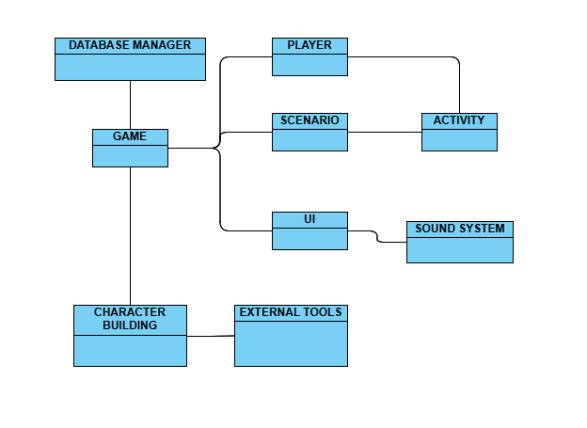

Figure 10 Alternative High-Level OOP Architecture

# Detailed Design

<**ToDo:**

* During semester 1, you will design, implement, and test **25% to 30% of the essential use cases** to deliver the core and most importantfeatures of your solution. In semester 2, you will complete the remaining use cases.
* In this section you need to document the detailed design specifications of the software components to meet the functional and the non-functional requirements of your project. The detailed design serves as a reference and actionable guidance for implementing the solution.
  + Use suitable methods and tools such as class diagrams, sequence diagrams, activity diagrams and state diagrams.
* Note that for every design aspect you will present in the sections below, you must:
* **Identify and evaluate possible alternative solutions** (i.e., design choices) and analyze their respective tradeoffs.
* Provide **detailed justifications** on why you have preferred and selected a particular solution or design choice over others. Highlighthow your design choicesenabled you to achieve the desired system quality attributes documented in *Section ‎3.2 Non-Functional Requirements*. Additionally, you should highlight the novel aspects of your design.

Further justify your design choices by discussing relevant **design principles** that influenced your system design. For example, highlight how your design complies with key software design principles such as separation of concerns, abstraction, modularity, high cohesion, and low coupling.

/>

## Structural model

<**ToDo:**

* **You may break this section into subsections** to clearly document the detailed structural model of each major component or use case.
* The structure of your software components could be documented using:
* Class diagrams to model the structure and relationships among classes, aiding in both conceptual understanding and practical implementation. If the model is too big, partition the diagram. For instance, you may present entity classes, repository classes, and service classes as separate diagrams.
  + - * For each class, provide specifications for attributes (names and data types) and methods (parameter names, types, and return types).
      * Clearly depict inheritance, composition, or aggregation relationships between classes. Define the association name and specify multiplicities at both ends.
      * Accompany each diagram with a succinct explanation. Include a few paragraphs discussing significant design decisions, such as how inheritance and polymorphism were employed to enhance system design. Additionally, briefly discuss how design principles such as the ‘Information Expert’ and ‘Whole controls the Parts’ principles were applied to your design.
* Design the interfaces exposed by external services that the system interacts with (e.g., BankingService, MailService). Specify input parameters, return types, and exceptions for each of these service interfaces.

/>

The class diagram was used to conceptually represent the logical structure of our system, showing the key entities, their attributes, methods, and relationships among them. It serves as a blueprint that helps visualize the core data models and functional responsibilities before implementation. However, our actual system is developed in Unity, where the architecture differs from traditional object-oriented software. Instead of implementing classes that directly store attributes and methods as shown in the diagram, Unity projects rely on scripts, GameObjects, and Assets that interact through components and event-driven behaviors. Each Unity script (e.g., UserManager, LevelController, ShopSystem) typically manages a specific functionality and communicates with others through the Unity engine rather than direct class associations. Because of this structural difference, the real implementation will not mirror the class diagram exactly. To better illustrate the Unity-based design, we will include other types of diagrams, such as activity diagrams, which are more effective for expressing the behavior and interactions of scripts, objects, and scenes in our game project.

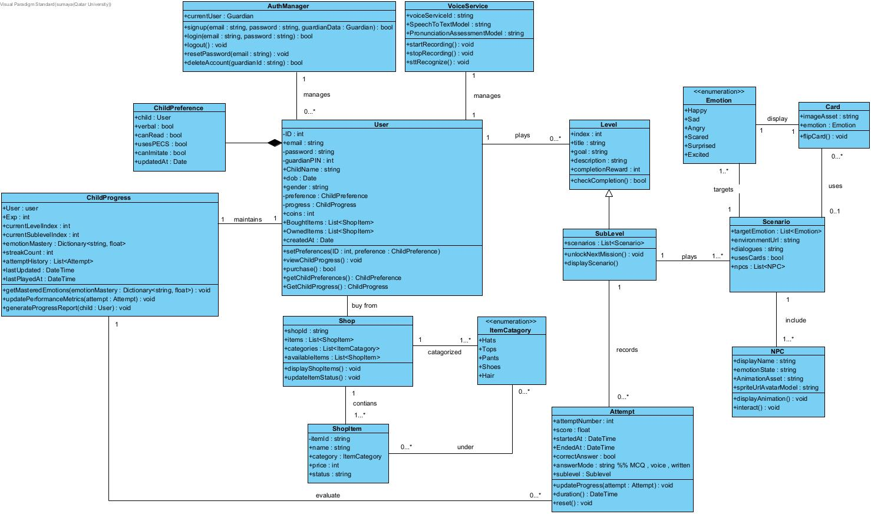

Figure 11 Class Diagram of Feel-o

**Class Specifications (Key domain classes)**

* **User**: This class represents the main guardian or player account that manages the child’s learning profile. It stores authentication data, preferences, and progress. The class provides methods to set preferences, view child progress, and make in-game purchases using earned coins.
* **ChilePreferences**: This class defines the individual child’s learning and interaction preferences. It personalizes gameplay based on the child’s communication and sensory needs (verbal, non-verbal, PECS use, imitation ability). The preferences are updated and retrieved through the User class.
* **ChildProgress**: This class maintains all performance metrics for the child. It stores experience points, level indices, emotion mastery scores, and attempt history. It provides methods to update performance after each attempt and to generate detailed progress reports for guardians or teachers.
* **Level**: This class represents the main stages of the learning journey. Each level contains general attributes like title, description, and completion rewards. It defines the checkCompletion() method to verify whether all sublevels have been successfully finished.
* **SubLevel**: A subclass of Level that includes specific scenarios and missions within a main level. It encapsulates concrete activities (such as observe, interact, and flashcards) and contains methods to unlock new missions and display the corresponding scenarios.
* **Scenario**: This class represents in-game situations where children interact to identify or express emotions. It holds details such as target emotions, dialogues, and related NPCs. Scenarios are dynamically loaded within sublevels to simulate different emotional contexts.
* **Card**: This class models the flashcards used to teach emotions visually. Each card stores an image asset and provides a flipCard() method to reveal the emotion. Cards are central to Levels 1–3, focusing on the five basic emotions before expanding to more complex ones.
* **Emotion (enum):** An enumeration defining the basic and advanced emotions used in the game (e.g., Happy, Sad, Angry, Scared, Surprised). It standardizes emotional states across all related classes such as Scenario and NPC.
* **Attempt:** This class records the outcome of a child’s activity attempt. It includes time, score, answer mode, and correctness. It provides methods to update progress metrics, calculate duration, and reset attempts. It acts as a key data point in tracking improvement and unlocking new missions.
* **NPC:** This class represents non-player characters that display and express emotions during gameplay. Each NPC has an animation, sprite, and current emotional state. Methods include displaying animations and interacting with the player to enhance immersion and feedback.
* **Shop:** This class manages the in-game reward shop. It stores available items, categories, and updates their status dynamically. It provides a displayShopItems() method to present items and updateItemStatus() to refresh their availability.
* **ShopItem:** This class represents a single customizable item available in the shop. It contains information such as name, price, and category, and is linked to player rewards to motivate continued learning and engagement.

**Service Classes:**

* **AuthManager:** This service class manages all user authentication and account-related operations using Firebase. It provides methods for signup, login, password reset, and account deletion. It ensures secure management of user credentials and guardian access.
* **VoiceService:** This service class supports speech-based interaction modes. It handles voice recording, speech-to-text recognition, and pronunciation assessment. It enhances accessibility for verbal learners by allowing them to answer and interact through voice commands.

**Relationships and multiplicities:**

* User sets ChildPreference (1..1) and records ChildProgress (1..1).
* Level contains SubLevel (1..*).
* Scenario uses Card (0..*) and NPC (0..*), and targets Emotion (1..*).
* Shop contains ShopItem (1..*).
* ChildProgress maintains Attempt history (0..*), each linked to a SubLevel.
* User buys from Shop (1) and owns ShopItem (0..*).
* Shop contains ShopItem (1..*), each belonging to an ItemCategory.
* AuthManager and VoiceService manage multiple User accounts (0..*).

## Behavioral model

<**ToDo:**

* **You may break this section into subsections** to clearly document the detailed behavioral model of each major component or use case. The behavioral model specifies the sequence of interactions between objects or components to depict how specific use cases are executed within the system.
* The behavioral aspects of your software components could be documented the following techniques:
* **Activity diagrams** to model the flow of activities and control logic within the system or a complex use case. They are particularly well-suited for modeling complex processes, workflows, or business logic. They capture conditional branching, parallel processing, and decision points.
* **Design Sequence Diagrams (DSD)** to document interactions and communication between objects or components over time to realize a specific use case. They emphasize the timing and dependencies of interactions. Ensure that method calls in the DSD use methods from the class diagram and must show the parameters and the return type of each method.
* **State diagrams** to represent the different states and transitions of important objects or components within the system. Describe the conditions triggering state transitions
* Present detailed algorithms for important functions within the software. Include pseudocode, or flowcharts to explain the logic.

/>

We used activity diagrams because they effectively model the flow of control logic within our use cases, making it easier to understand how our Unity game operates behind the scenes. Since the game scenarios are complex and involve multiple branching paths, activity diagrams help visualize how actions and decisions unfold in real time during gameplay. This modeling approach perfectly fits our project because the game is event-driven, involving interactions such as clicking buttons, unlocking levels, and displaying feedback; therefore, activity diagrams were an ideal choice to represent these dynamic events and behaviors clearly.

**UC01 – Sign up**:

Figure 12 shows how the guardian signs up by entering valid credentials and creating a child account. It clearly represents the validation steps, account creation, and confirmation flow. We chose this design because it reflects the real logic in Unity, where the system checks input fields, verifies Firebase authentication, and then switches scenes to the next step.

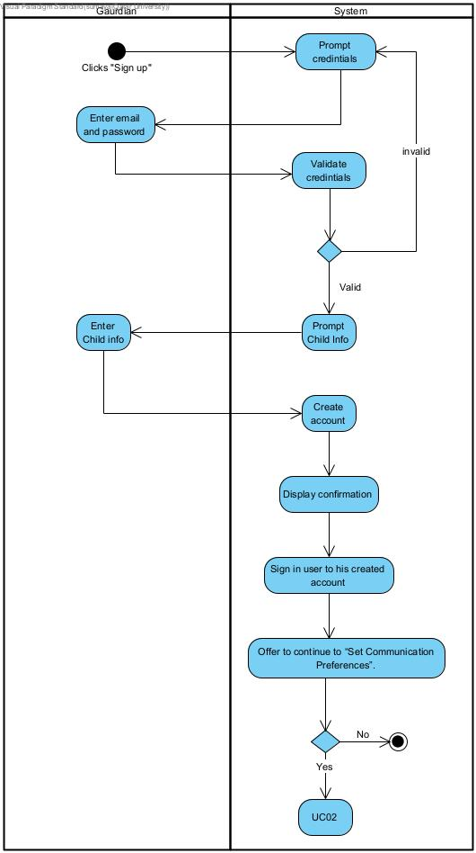

Figure 12 Activity Diagram for Sign up

**UC05 – Login:**

Figure 13 explains the authentication process for the child user. It visualizes the “valid” and “invalid” credential paths and how the system decides which scene to load next.

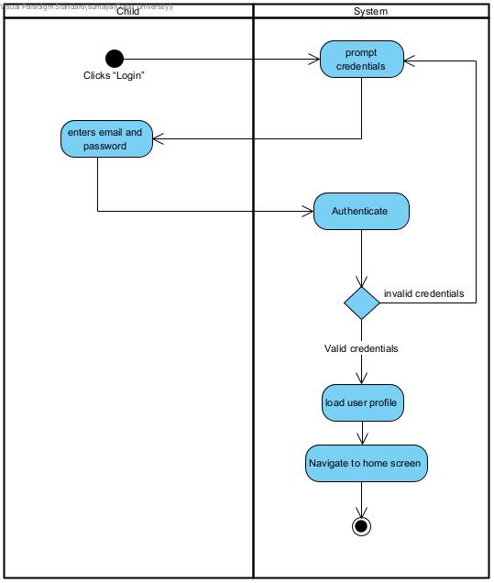

Figure 13 Activity Diagram for Login

**UC02 – Set Communication Preferences**

Figure 14 shows how the guardian sets the child’s learning and communication preferences, starting with entering a secure PIN. This helped us organize the logic behind saving preferences in Firebase and locking access behind a PIN. The flow in the diagram mirrors the UI interactions in Unity, choosing settings, confirming them, and deciding whether to continue to the assessment scene.

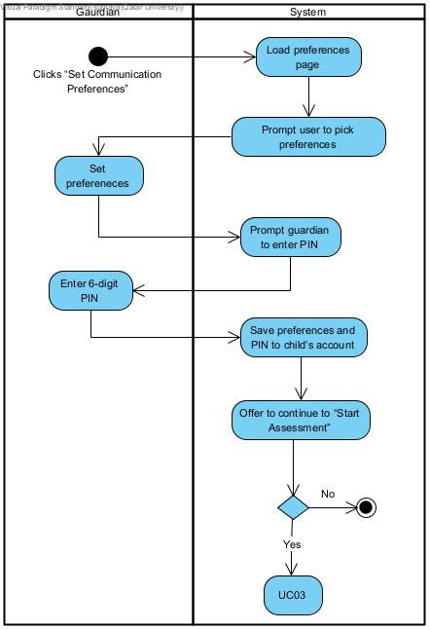

Figure 14 Activity Diagram for Set Child Preferences

**UC03 – Take Assessment**

Figure 15 helped us understand the sequence of the assessment process, starting off with showing instructions, then showing the flow of the child taking the test, computing his score, and deciding if the child can move on. It also shows optional paths like retaking or proceeding anyway. This matches how we implemented the assessment in Unity, where we use condition checks to determine if the child passes and can continue to the tutorial.

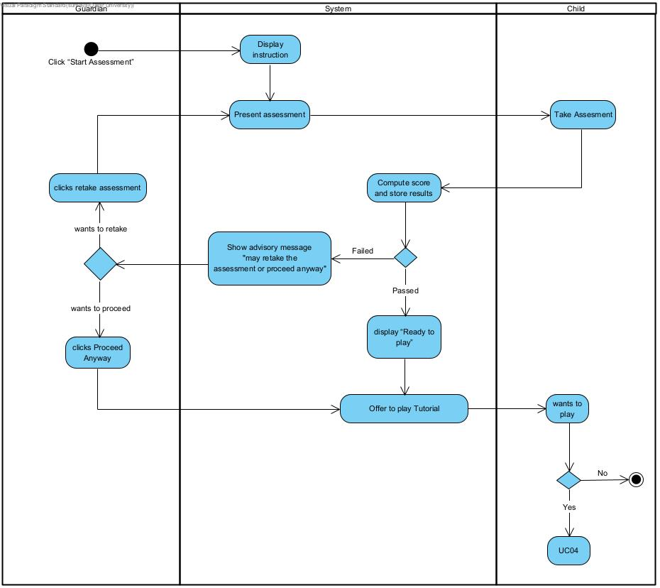

Figure 15 Activity diagram for Take Assessment

**UC04 – Take Tutorial**

Figure 16 represents how the child interacts with the tutorial scene, learning the basic game layout before starting real levels.

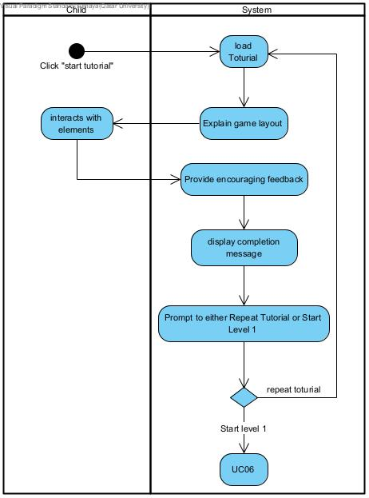

Figure 16 Activity diagram for Tutorial

**UC06 – Play Level**

The play level diagram shows how sublevels are unlocked, and how performance is evaluated, and how progress is updated. It was especially useful for designing the “three-perfect-attempts” streak logic in Unity. The repeated decision branches for checking streaks and unlocking the next sublevel match exactly how we scripted our level manager and progress tracking system.

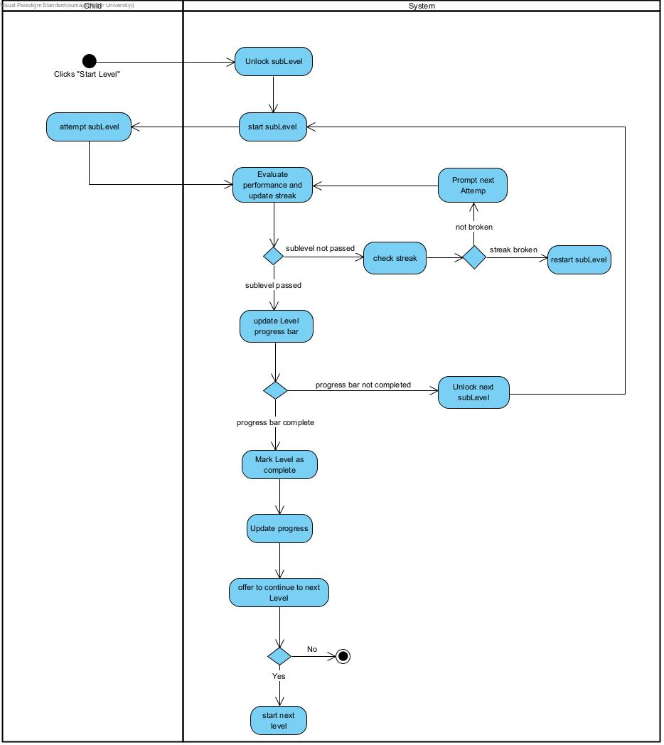

Figure 17 Activity diagram for Play Level

**UC07 – Edit Character**

Figure 18 shows the flow for customizing the player’s character. It helped us plan how to load available customization options, apply changes, and save them. In Unity, this corresponds to UI buttons, selection menus, and saving customization data making it easier for us to organize the logic for character personalization.

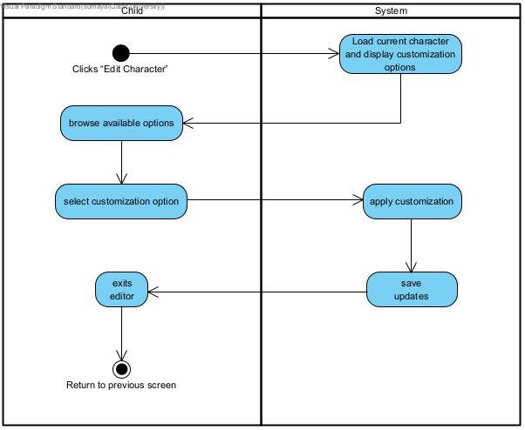

Figure 18 Activity diagram for edit character

**UC08 – In-Game Shop**

Figure 19 shows how the child browses items, checks if they have enough reward coins, and confirms purchases. It clearly separates the paths for sufficient and insufficient rewards.

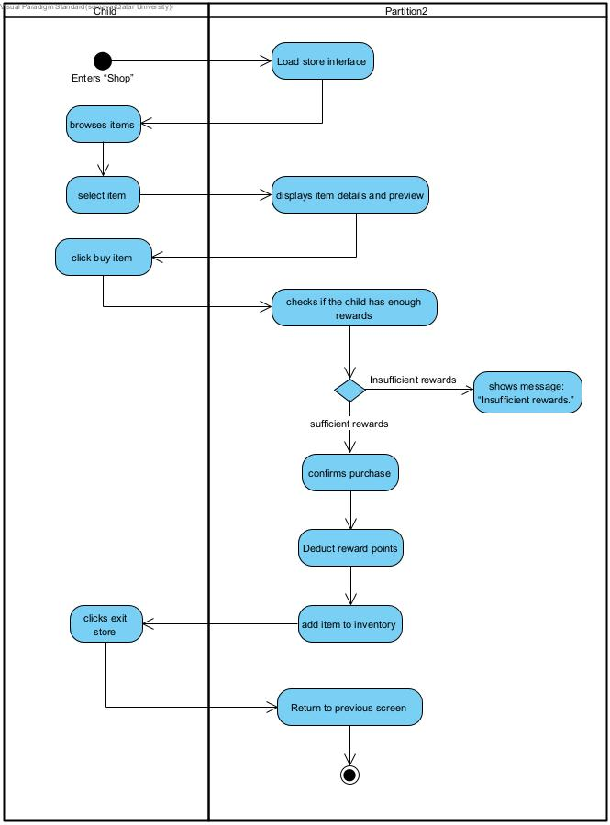

Figure 19 Activity diagram for shopping

**UC09 – View Progress**

Figure 20 explains how the system displays the child’s progress map and handles navigation through complete and current sublevels.

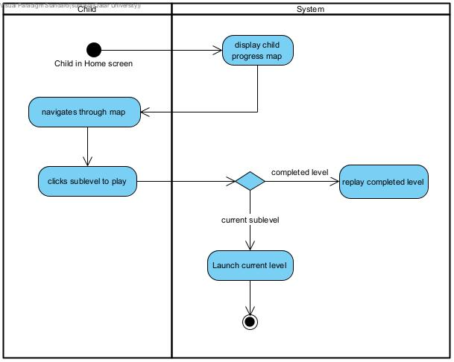

Figure 20 Activity diagram for child view his progress

**UC10 – View Progress Dashboard (Guardian)**

Figure 21 shows how the guardian enters a PIN to view the child’s progress dashboard. It helped us structure the flow for PIN validation then loading the dashboard and selecting the display format. This matched our Unity implementation, where the system first authenticates the guardian then dynamically loads progress data from Firebase.

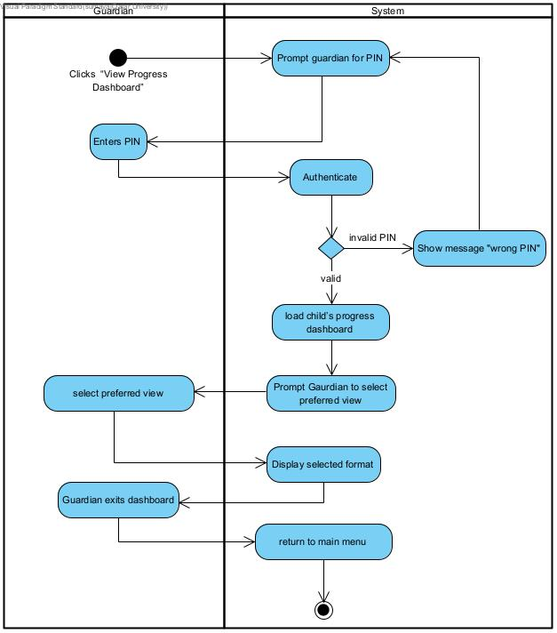

Figure 21 Activity diagram for guardian view child progress

## Database design

<**ToDo:**

* Include a logical data model describing the major entities, their relationships, associated attributes, and respective data types . Ensure that the data model is consistent with (or derived from) the entities of the class diagram. If the model is too big partition the diagram into logical parts, such as generating separate diagrams for each component or subsystem.

/>

Our database design uses a NoSQL document-based structure hosted on Firebase Firestore. We chose this approach because it’s cloud-based, fast, and automatically keeps data in sync across devices which fit perfectly with the interactive and real-time nature of our game. Unlike regular SQL databases, Firestore doesn’t use foreign keys; instead, we connect documents using their IDs, which makes the database easier to scale and faster to query.

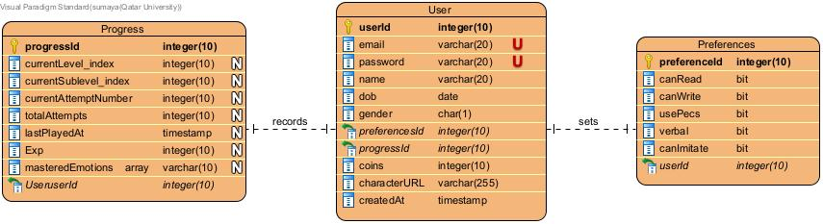

Figure 22 ER diagram for Feel-o

**Primary entities**

* **User**: Player profile managed by Guardian, played by child; holds credentials (via Auth), child data, and is linked to Preferences and Progress via foreign keys.
* **Preferences**: communication/learning settings (verbal, read/write, PECS usage, etc) chosen in UC02.
* **Progress**: child gaming status (current level/sublevel, mastery, attempts, XP, timestamps); Used in UC10.

**Key relationships**

* User sets Preferences (1–1). each user has exactly one preferences record; enforced via FK and unique constraint on Preferences.userId.
* Progress records User game status (1–1). each user has exactly one progress record; enforced via FK and unique constraint on Progress.userId.

**Entities and attributes**

* **User**
  + userId (int) PK
  + email (varchar[20]), password (varchar[20])
  + name (varchar[10]), dob (date), gender (char[1]) (M for Male , F for female)
  + FKs: preferenceId (int), progressId (int)
  + coins (int), boughtItemIds (array <int>) (bought items Fks), equippedItemIds (array<int>)(equipped items FKs)
  + createdAt (timestamp)
* **Preferences** 
  + preferenceId (int) PK, userId (int) FK
  + canRead (bit), canWrite (bit), usePecs (bit), verbal (bit), canImitate (bit) (visual paradigm doesn’t have Boolean as a data type so users most commonly use bit to represent Boolean as 0 equals False and 1 equals True)
* **Progress** 
  + progressId (int) PK, userId (int) FK
  + currentLevel_index (int), currentSublevel_index (int)
  + currentAttemptNumber (int), totalAttempts (int)
  + lastPlayedAt (timestamp), Exp (int)
  + masteredEmotions (array<varchar[10]>)

**Integrity, Constraints & Validation**

* Uniqueness: userId, progressId, preferenceId are unique. User email must also be unique to prevent duplicate accounts.
* Referential integrity: Preferences.userId and Progress.userId are required and reference the same User. Deleting a user removes linked preferences and progress.
* Domain rules: coins, Exp, and currentLevel_index must be non-negative integers; dob must be a valid past date; gender limited to (M/F).
* Validation: Boolean fields (canRead, canWrite, usePecs, verbal, canImitate) only accept true/false values.
* Data consistency: Each user can have only one linked Preferences and one Progress record.
* Automatic fields: createdAt and lastPlayedAt timestamps are system-generated to track activity accurately.

## User interface design

<**ToDo:**

* Discuss the target users and highlight relevant characteristics that influenced the design decisions.
* Describe the overall layout and visual design of the user interface, including aspects such as color schemes, typography, and graphics.
* Include screen mockups or wireframes for major use cases and explain the rationale behind key design decisions.
* Discuss the navigation design of the UI, including navigation aids or controls for moving between screens to achieve a particular use case.
* Explain any novel aspects of your UI design and how they enhance the usability of your system. This could include innovative interactions, user feedback mechanisms, or features that support accessibility or personalization. />

The target users of Feel-o are children with Autism Spectrum Disorder (ASD), which directly influenced the visual, environmental, and interaction design decisions throughout the game. Children with ASD often experience sensory sensitivities and respond best to predictable, low-stimulus environments. As a result, both the user interface and in-game environments were intentionally designed to be calm, structured, and free from unnecessary visual or auditory distractions or noise.

The gameplay settings depict familiar, everyday contexts such as a home, classroom, or playground to create a sense of comfort and relatability, as well as to encourage the children to apply their learnt emotional skills in daily life. These environments avoid overstimulation by using soft colors, minimal background movement, and gentle sound effects, ensuring that attention remains focused on the emotional-learning activities rather than the surroundings.

The name Feel-o, derived from the word “feel”/”feeling”, was initially chosen to reflect the game’s core purpose of helping children with ASD learn to understand and express emotions. Then the team recognized that Feel-o also mirrors the Arabic word “feel” (فيل), meaning “elephant.” This connection inspired the inclusion of an elephant mascot, creating a natural link between the game’s name and its visual identity while also adding cultural relevance for Arabic-speaking children. To further support this choice, research has shown that children with ASD display more positive social behaviors, such as eye contact, smiling, and verbal interaction, in the presence of animals compared to toys, along with reduced self-focused and negative behaviors [48]. This finding suggests that animal figures can foster a stronger sense of connection and emotional engagement than fictional or abstract characters. Therefore, Feel-o features a friendly elephant designed to evoke comfort, warmth, and emotional safety.

The color palette of soft blue and white complements this design by reinforcing a calm, stable atmosphere [49] and visually connecting to the elephant mascot. The color scheme and mascot can be seen in figures 23 and 24, respectively.



Figure 23 Color Palette



Figure 24 Feel-o the Mascot

**Screen Mockups/Wireframes of the UI:**

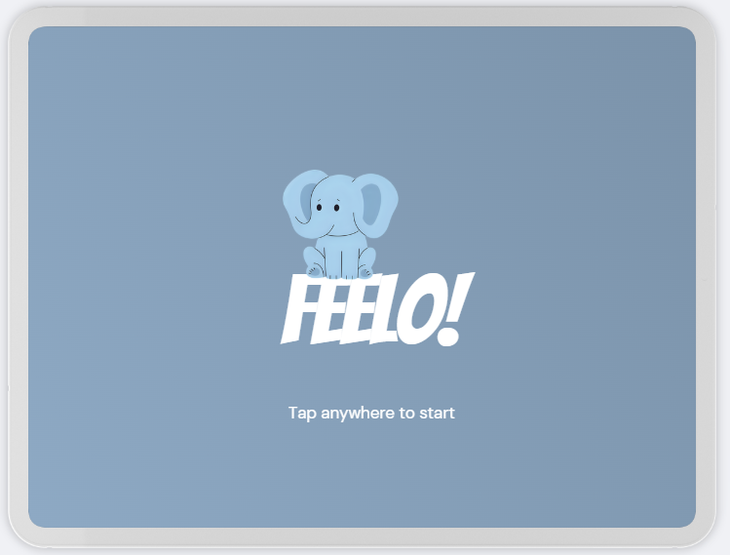

Figure 25 Splash Scene

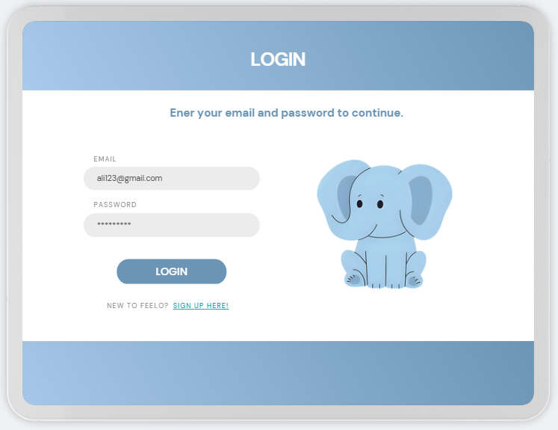

Figure 26 Login Scene

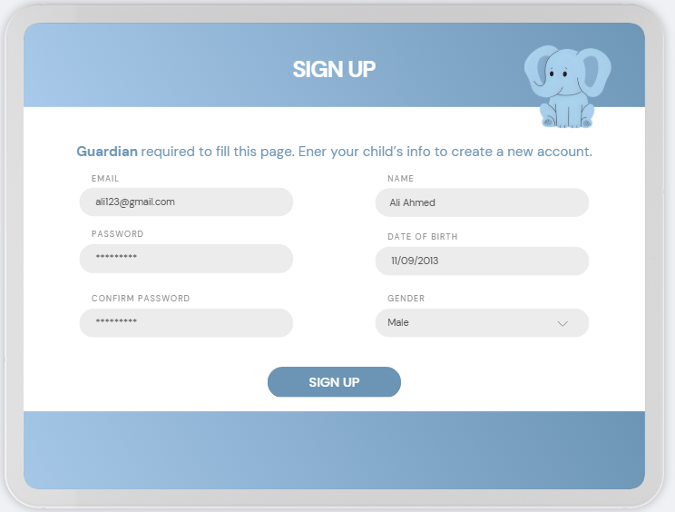

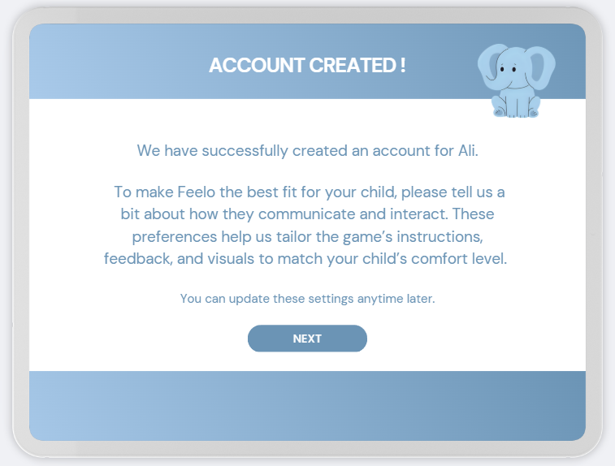

Figure 27 Sign Up Scene

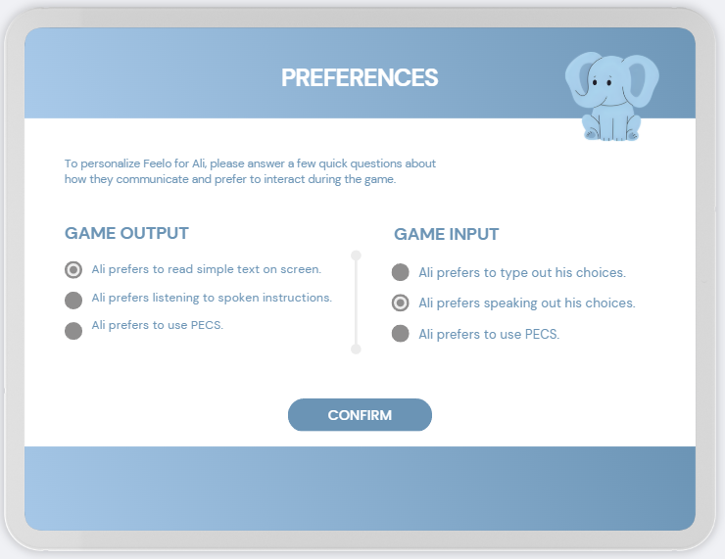

Figure 28 Set Preferences Scene

**Level 1 Wireframe**

|  |  |
| --- | --- |
| **UI Sketch Label** | Sketch |
| Progression Map of Levels  When level is clicked, pop-up will display the child’s progress if there is the start button. |  |
| Quest UI Pop-up of the Sub-level  States what the tasks of the child are in this sub-level and can be played audibly. |  |
| Movement Joysticks UI  Control UI available for the child to move around:  - Move Joystick  - Jump Button  - Sprint Button  - Right area of the screen to swipe to look around |  |
| Level 1: Sub-Level 1.1  The child can approach any NPC to trigger an interaction or cut scene.  This cut scene leads into the next scene where it is a close of the NPC’s face teaching them the emotions. |  |
| Level 1: Sub-Level 1.1  Close-up Scene displaying the emotion.  This close-up scene displays the emotion of the NPC teaching the child to identify.  The emotion can be read, seen, and heard audibly. |  |
| Level 1: Sub-Level 1.2  In this level, the NPC is able to approach the player and vice versa to start a conversation.  This triggers an interaction in which the child will be exposed to the emotions again a |  |
| Tasks to be done may be MCQ or just choice of response. |  |
|  |  |
| Level 1: Sub-Level 1.3  In this task, the child approaches certain trigger areas like the table to start the interaction with an NPC and do Flash Cards. |  |
| When the card on the table is tapped it flips to reveal the name of the emotion. |  |
| When the card on the table is 'swiped’, the next card should swipe in and out to exchange. |  |
| Shop for Character Customization  This is where the children can use and redeem all the ’Feel-oos’ they have earned through tasks.  This is unlocked after a few sub levels done. |  |

Figure 29 Level 1 UI

## Design patterns

<**ToDo:**

* Document and evaluate the design patterns applied to your design such as the Model View Controller (MVC) pattern, the Factory pattern, the Proxy pattern, the Adapter etc.
* For each selected architectural pattern:
* Discuss the design rationale justifying the choice of the selected design pattern.
* Draw a UML diagram(s), e.g., class diagram, sequence diagram, to illustrate how the selected design pattern has been applied to your design.
* Evaluate the impact of selected pattern on your system quality attributes. Highlight the benefits and potential problems or limitations introduced by the selected pattern.
* This subsection is extremely important and required. />

This section discusses the architectural design patterns applied in the development of the system. Each selected pattern is described with its purpose, design rationale, and impact on the system’s quality attributes.

Note that the accompanying UML diagrams are conceptual illustrations used to demonstrate how the patterns were applied. They are simplified representations that focus on design relationships rather than complete class-level details (i.e., they do not include all attributes, operations, or technical elements).

**Singleton Pattern**

The Singleton design pattern was applied in this project to manage the Firebase connection through a single, persistent instance of the FirebaseManager class. This ensures a consistent and centralized connection to Firebase Authentication and Firestore across all scenes.

In Unity, multiple scenes are loaded at runtime; initializing Firebase in each one would create redundant connections, consume extra resources, and risk data synchronization issues. To prevent this, the FirebaseManager implements a Singleton that persists between scenes using DontDestroyOnLoad().

In Unity, MonoBehaviour scripts cannot use constructors for object instantiation, so the initialization logic is handled within the Awake() method. This provides the same guarantee as a private constructor in traditional C# Singletons, allowing only one instance to exist throughout the application’s lifecycle. All classes that require Firebase functionality (e.g., AuthUI, PreferencesUI) access the same instance via the static property FirebaseManager.Instance. Figure 25 illustrates this relationship using a class diagram.

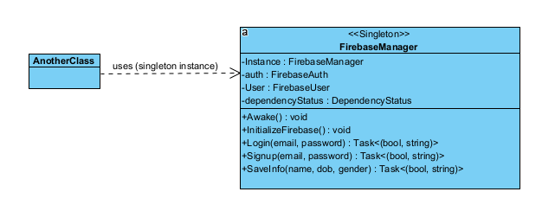

Figure 30 Singleton Pattern

Impact of using Singleton:

* Maintainability: Centralizes Firebase operations, simplifying debugging and future updates.
* Reliability: Ensures a single source of truth for authentication and data storage.
* Performance: Prevents redundant Firebase initializations, improving efficiency.
* Extensibility: Allows additional Firebase services (e.g., Firestore, Storage) to reuse the same manager.
* Testability (limitation): The global static instance can complicate isolated unit testing due to tight coupling.

**MVC Pattern**

The Model-View-Controller (MVC) pattern was applied as a design approach in parts of the project - for example, within the user interface and authentication system. This pattern promotes a clean separation between data management, user interface, and control logic, thereby enhancing modularity and scalability.

For example, in the authentication system:

* The Model is represented by the FirebaseManager, which handles data logic related to Firebase Authentication and Firestore.
* The View consists of Unity UI elements such as the login_ui and signup_ui panels that display content and collect user input.
* The Controller is implemented through the AuthUI script, which mediates between the interface and the backend. It captures button clicks, validates user input, and triggers FirebaseManager methods (e.g., Login(), Signup()).

The MVC interaction is bidirectional: while the View captures user input and sends it to the Controller, the Model asynchronously returns operation results (e.g., login success or error messages), which the Controller then uses to update the View. This dynamic exchange ensures separation of concerns while maintaining responsiveness and clarity in the codebase. Figure 26 illustrates this structure as implemented within the authentication component.

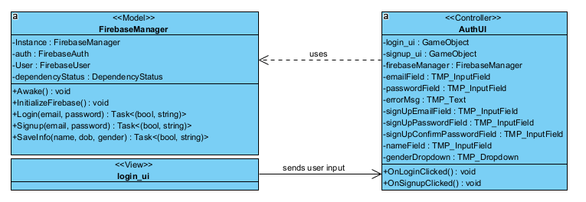

Figure 31 MVC Pattern

Impact of Using MVC:

* Modularity: Each component (Model, View, Controller) can evolve independently, simplifying maintenance.
* Reusability: Core logic (e.g., Firebase operations) can be reused across multiple UI scenes.
* Maintainability: Logical separation enhances debugging and future development.
* Scalability: Supports the addition of new UI screens and backend operations without rewriting the structure.
* Complexity (Limitation): The pattern introduces additional layers of communication, which may add overhead in smaller module.

# 6.6 Privacy and Security Design

## 6.6.1 Concept of Privacy in Feel-o

One of the main design considerations we included in Feel-o was Privacy since our game records sensitive information about the child such as their emotional learning progress and their ASD diagnosis, and since our game is developed for children it prioritizes data minimization, consent-based access, and controlled data visibility. Our game only collects information that is strictly necessary to support its learning functions, such as user credentials, preferences, and game progress. No personally identifiable information (PII) about the child are publicly visible or shared with third parties. We ensured that our game is complied with modern data protection standards by using privacy-by-design principles in our system, we made sure all user interactions that involve personal data are handled through secure encrypted channels, and made user accounts isolated in the database to prevent unauthorized access. Furthermore, we made guardians have explicit control over creating child’s account and setting his preferences, and his progress tracking, in order to reinforce the ethical responsibility of informed consent and transparency in data handling. We made sure these privacy measures align with ethical frameworks and global privacy principles such as the General Data Protection Regulation (GDPR) and the Children’s Online Privacy Protection Act (COPPA).

## 6.6.2 Secure Authentication Using Firebase

We used Firebase Authentication for identity management to ensure a secure and frictionless login experience. It allows guardians to sign up and log in using their email and password, while Firebase handles all the technical parts securely in the background. Instead of storing passwords directly on the device, Firebase uses token-based authentication (JSON Web Tokens, or JWTs), which keeps the login process safe from common attacks like credential theft or replay attacks. Firebase also takes care of important security details automatically it refreshes login tokens and enforces session timeouts, and ensures that all communication happens over HTTPS. Passwords are secure in Firebase, since passwords are hashed and salted using strong cryptographic methods automatically before being stored, so even Firebase staff can’t see them in plaintext. In future updates, we plan to include multi-factor authentication (MFA) for guardians to provide an additional layer of protection.

## 6.6.3 Secure Database Design and Data Protection

Feel-o’s data is stored and managed through Firebase Cloud Firestore, a cloud-based NoSQL database that allows real-time synchronization while keeping user information secure and private. The security in Firestore is controlled using Firebase Security Rules, which act as protective filters for all data requests, these rules make sure that only authenticated users can read or write their own data. Additionally, all data stored in Firestore and Firebase Cloud Storage is encrypted both in transit and at rest, using strong AES-256 encryption which means that even if someone intercepts the data or gains access to the storage, it will remain unreadable and protected, Together, these measures make Feel-o’s database not only functional and efficient but also secure and trustworthy.

# Implementation

## Hardware/software used

< **ToDo:**

* List in a table and justify the hardware/software platforms and tools used for the design and implementation.
* Explain why each technology was chosen and its role within the architecture.
* Provide links to relevant documentation for each hardware or software component.

/>

The development of Feel-o required a combination of software tools for design, animation, programming, and collaboration. Table 9 lists all hardware and software platforms used throughout the project, along with their justifications and official documentation sources.

Table 9. Hardware/software to be used

|  |  |
| --- | --- |
| HW/SW details | Justifications |
|  | Unity is as the main game engine to build, test, and deploy Feel-o. It supports both 2D and 3D environments.  <https://docs.unity.com/en-us> |
| VS Code icon Visual Studio logo and symbol, meaning, history, PNG | Visual Studio code & Microsoft Visual Studio are used as the integrated development environment (IDE) for writing and debugging C# scripts within Unity. They offer seamless Unity integration.  <https://learn.microsoft.com/en-us/visualstudio/gamedev/unity/get-started/visual-studio-tools-for-unity?pivots=windows>  <https://code.visualstudio.com/docs/other/unity> |
| Sims Icon, Game Logo, Video Transparent PNG | Sims 4 is used as a creative source for importing base 3D character models. Sims provides visually expressive avatars that have been adapted for in-game emotional modeling. <https://www.ea.com/games/the-sims> |
|  | Mixamo is used to generate realistic movement animations for the characters. It offers pre-built, rigged animations that can be imported into Unity.  <https://www.mixamo.com/#/> |
|  | Blender is used to model, customize, and refine character facial expressions and shapes before importing into Unity. Blender’s open-source 3D modeling tools support precision control of mesh and rigging. <https://docs.blender.org/> |
|  | Firebase is used for authentication, database storage, and cloud integration. Ensures user data persistence (such as progress, preferences, and rewards). <https://firebase.google.com/docs> |
|  | Visual Paradigm is used for software modeling, including UML diagrams (use cases, activity diagrams, class diagrams). Supports consistent documentation and clear architectural visualization. <https://www.visual-paradigm.com/support/documents/> |
| Canva Logo PNG Images For Free Download - Freelogopng | Canva is used for designing the visual layout and UI elements of the game. Provided a platform to create consistent mockups and design assets for menus, buttons, and instructional screens before implementation.  <https://www.canva.com/help/> |
|  | Microsoft Project is used for planning and milestone tracking, as shown in Section 4 (Gantt chart). The tool helped organize project phases, visualize task dependencies, and monitor progress across development cycles. <https://learn.microsoft.com/en-us/project/> |
| GitHub Logo, symbol, meaning, history, PNG, brand | Github is used for version control and collaborative development. Allows the team to manage code changes, track history, and collaborate effectively.  <https://docs.github.com/en> |
| iPad (Testing Device) | Used to test the game’s performance, interface, and usability on an actual iOS platform. Ensures that controls, resolution, and user experience are as expected. |

## Challenging issues and solutions

<**ToDo:**

* Discuss the challenging issues encountered during the implementation and how they were addressed.
* Present lessons learnt from this experience, offering valuable insights and guidance to benefit others in similar situations.

/>

# Testing and evaluation

<**ToDo:**

* During semester 1, you will test the use cases you have implemented. Then in semester 2 you will complete the testing of the whole solution.

In this section, you should describe in detail the tests you have conducted to verify that your design and implementation satisfy the desired functional and non-functional requirements. The testing should verify and provide evidence that your solution solved the stated problem and satisfied the requirement specifications (if not, explain what is lacking).

Note that this section is a substantial portion of the grade for your project, and it requires a significant effort.

/>

## Functional testing

<**ToDo:**

* Break this section into multiple subsections to test every use case.
* Testing should be done for different levels including at least **Unit Testing (a.k.a., component testing),** **Integration Testing, System Testing, and Acceptance Testing** to verify the correct delivery of the desired use cases documented in Section ‎3.1.
* Describe in detail the tests you have run to verify that your solution satisfies the functional requirements of your project. For example, for each use case, you should write test case(s) including the expected and actual results, run them and report the testing results. The test cases should be added to *Appendix B - Test cases specification*. Functional testing will allow you to find errors and defects, then fix them and identify possible improvements. You need to have a comprehensive set of tests that verify the correct functionality of every use case of your system.
* You should **present the test results**, with the appropriate level of detail in addition to accuracy and completeness**,** using tables, graphs, diagrams, screenshots, etc.
* **Discuss test results** and explain whether the implemented solution has satisfied the requirements. If not, state what is lacking or still needs improvement, then explain the reason for that.

/>

## Non-functional testing

<**ToDo:**

* Include a sub-section for each non-functional requirement listed in Section ‎3.2.
* Describe in detail the tests to **evaluate the quality of the system** (e.g., performance testing, usability testing, security testing, scalability testing, availability testing, etc. as documented in Section ‎3.2) to verify that your solution satisfies the non-functional requirements of your project. Include a summary table that shows each non-functional requirement and the measurements that prove your system met/did-not-meet the requirement. In case a requirement is not met, then explain the reason for that.
* You should **present the test results**, with an appropriate level of detail in addition to accuracy and completeness**,** using tables, graphs, diagrams, screenshots etc.
* **Discuss test results** and explain whether the implemented solution has achieved the requirements. If not, state what is lacking or still needs improvement, then explain the reason for that.

/>

# Conclusion

< **ToDo:**

* Discuss the main conclusions (e.g., match the project objectives with the achievements in your work and state the degree of attainment).
* Highlight the strengths of the solution and list its shortcomings (what worked? what didn’t work?).
* Highlight the key contributions and the novel aspects of your work.

/>

# Future work

< **ToDo:**

* You may complete this section in Semester 2.
* Suggested improvements and further work: identify areas of improvement in the project and features of interest that can be added later. How the solution shortcomings could be addressed? What things could be done better? What additional resources are required to implement the extended / not-implemented design or features?

/>

# Student reflections

< **ToDo:**

* Add a sub-section for each student individual reflections:
* Describe the professional development accomplished during the project, including any (1) newly acquired technical skills, (2) interpersonal skills in areas like team leadership and effective communication (3) personal growth such as adapting to change and professional and ethical conduct. Explain the value of these newly acquired skills for your future career advancement.
* Identify key shortcomings encountered during the project that you should avoid in future projects.
* Summarize significant lessons learned from the project you intend to carry forwards to your professional life from the personal experiences and the teamwork experienced during the project.

/>

# References

< **ToDo:**

* Include the list of references relevant to your work using [IEEE citation style](https://www.ucalgary.ca/ssc/files/ssc/ieee-documenting-sources_0.pdf). Use good quality references such as journal and conference papers from ACM, IEEE and Springer. Embed citations of the references in the text of your document.
* You can get the PDF documents of good quality papers related to your work from IEEE, ACM and Springer via QU Journal Databases @ <https://www.qu.edu.qa/library/tools-collections/databases>

A better way is to search via <https://scholar.google.com> (if you do it in QU Campus you can easily get the paper PDF for free).

* Remember, always seek your supervisor’s advice and feedback.

/>

[1] C. A. Mazefsky, J. Herrington, M. Siegel, A. Scarpa, B. B. Maddox, L. Scahill, and S. W. White, “The role of emotion regulation in autism spectrum disorder,” *Journal of the American Academy of Child and Adolescent Psychiatry*, vol. 52, no. 7, pp. 679–688, Jul. 2013, doi: 10.1016/j.jaac.2013.05.006.

[2] Hamad Bin Khalifa University, “QBRI insights into autism,” *HBKU*, Apr. 4, 2021. [Online]. Available: <https://www.hbku.edu.qa/en/news/qbri-insights-autism>

[3] United Nations, “The 17 Goals,” *Department of Economic and Social Affairs – Sustainable Development*, [Online]. Available: [https://sdgs.un.org/goals](https://sdgs.un.org/goals?utm_source=chatgpt.com).

[4] World Health Organization, “Autism spectrum disorders—Key facts,” 2025.

[5] K. A. Shaw et al., “Prevalence and Early Identification of Autism Spectrum Disorder Among Children Aged 4 and 8 Years—ADDM Network, United States, 2022,” MMWR Surveill. Summ., vol. 74, no. 2, 2025.

[6] F. Alshaban et al., “Prevalence and correlates of autism spectrum disorder in Qatar: a national study,” J. Child Psychol. Psychiatry, vol. 60, no. 12, pp. 1254–1268, 2019.

[7] M. Abdi et al., “Genomic architecture of autism spectrum disorder in Qatar: The BARAKA-Qatar Study,” Genome Med., vol. 15, no. 81, 2023.

[8] L. B. Bilius et al., “The Age-Reward Perspective: A Systematic Review of Reward Mechanisms in Serious Games for Older People,” in Proc. ACM IMX, 2024.

[9] DataM Intelligence, “Digital Therapeutics Market to Surpass US$39.52 Billion by 2033,” 2025.

[10] T. Carneiro, A. Carvalho, S. Frota, and M. G. Filipe, “Serious Games for Developing Social Skills in Children and Adolescents with ASD: A Systematic Review,” Healthcare, vol. 12, no. 5, 2024.

[11] J. Serrano et al., “Digital serious games for emotional recognition in people with autism: A systematic review,” Rev. Neurosci., vol. 31, no. 1, 2020.

[12] F. F. Liu et al., “Fostering socio-emotional competencies in children on the autism spectrum via a serious game: Zirkus Empathico,” Molecular Autism, vol. 8, no. 49, 2017.

[13] P. Ducharme et al., “A ‘Proof of Concept’ Randomized Controlled Trial of a Biofeedback Videogame for Children With Emotional Dysregulation,” J. Child Adolesc. Psychopharmacol., 2021.

[14] S. R. Wintner et al., “Evaluation of a scalable online videogame-based program for child emotion regulation,” Internet Interventions, vol. 28, 100527, 2022.

[15] X. Yang et al., “Effectiveness of Virtual Reality Technology Interventions in Children and Adolescents with ASD: Systematic Review,” J. Med. Internet Res., 2025.

[16] V. Ravindran et al., “Virtual Reality Support for Joint Attention Using the Floreo Platform: Feasibility Pilot,” JMIR Pediatr. Parenting, vol. 2, no. 2, e14429, 2019.

[17] Vanderbilt Kennedy Center (TRIAD), “Progress Monitoring Tools for Autistic Learners: Data Collection Overview,” 2020.

[18] M. Y. Kim et al., “Game-based digital therapeutics for children and adolescents,” Front. Psychiatry, vol. 13, 986687, 2022.

[19] National Research Council, Educating Children with Autism, National Academies Press, 2001.

[20] B. K. Barnhart and J. L. Franklin, “Bridging the Gap: Strategies for Generalization in Autism Interventions,” Behav. Anal. Pract., vol. 15, 2022

[21] World Health Organization, Autism Spectrum Disorders: Key Facts, WHO, Apr. 2024.

[22] Centers for Disease Control and Prevention, Autism Spectrum Disorder (ASD): Data and Statistics, CDC, 2024.

[23] American Psychiatric Association, Diagnostic and Statistical Manual of Mental Disorders (DSM-5-TR), 5th ed., 2022.

[24] S. Baron-Cohen et al., “Recognition of facial expression of emotion in autism: A developmental study,” J. Child Psychol. Psychiatry, vol. 38, no. 7, pp. 813–822, 1997.

[25] A. Harms, R. Martin, and J. Wallace, “Facial emotion recognition in autism spectrum disorders: A meta-analysis,” J. Autism Dev. Disord., vol. 40, no. 10, pp. 249–263, 2010.

[26] S. Sivathasan et al., “Basic emotion recognition of children on the autism spectrum is enhanced in music and typical for faces and voices,” PLoS ONE, vol. 18, no. 1, e0279002, 2023.

[27] D. Milton, “On the ontological status of autism: The ‘double empathy problem’,” Disability & Society, vol. 27, no. 6, pp. 883–887, 2012.

[28] C. Kasari et al., “Comprehensive interventions for children with autism spectrum disorder,” J. Clin. Child Adolesc. Psychol., vol. 43, no. 4, pp. 676–698, 2014.

[29] H. Fletcher-Watson et al., “Intervention research for autism: Issues in generalization and maintenance,” Autism, vol. 8, no. 3, pp. 201–214, 2004.

[30] K. Parsons and P. Mitchell, “The potential of virtual reality in social skills training for people with autistic spectrum disorders,” J. Intellect. Disabil. Res., vol. 46, pp. 430–443, 2002.

[31] N. Honorato et al., “Gameful strategies in the education of autistic children: A systematic literature review,” Smart Learning Environments, vol. 11, art. 25, 2024.

[32] A. Landowska et al., “Automatic emotion recognition in children with autism: A systematic literature review,” Sensors, vol. 22, no. 4, art. 1649, 2022.

[33] J. Gao et al., “The effect of game-based interventions on children and adolescents: A meta-analysis,” Front. Psychol., 2025.

[34] L. Levy et al., “A real-time environmental translator for emotion recognition in autism spectrum disorder,” Sci. Rep., vol. 14, art. 31527, 2024.

[35] Project Group (AI-based Gamified Emotional Learning App for ASD), App Description and Design Objectives, Qatar University SDP Report (2025).

[36] C. Miller, “Autism Terminology,” Child Mind Institute, 12 June 2024. [Online]. Available: https://childmind.org/article/autism-terminology/

[37] O. Golan et al., “Enhancing emotion recognition in children with autism spectrum conditions: An intervention using animated vehicles with real emotional faces,” J. Autism Dev. Disord., vol. 40, no. 3, pp. 269–279, 2010.

[38] T. Gev, R. Rosenan, and O. Golan, “Unique effects of The Transporters animated series and of parental support on emotion recognition skills of children with ASD,” Autism Research, vol. 10, no. 5, pp. 993–1003, 2017.

[39] S. Baron-Cohen, S. Golan, and O. Hill, MindReading: The Interactive Guide to Emotions, Autism Research Centre, Cambridge University, 2004.

[40] H. R. Reese, “Digital emotion-recognition tools for children with autism: Evaluating usability and learning design,” Comput. Educ., vol. 191, 2022.

[41] EmoFace, Official Platform Overview, EmoFace Technologies, France, 2023. [Online]. Available: https://www.emoface.fr/en/

[42] Autism Society of America, Autism Emotions App Description and Usage Guide, Autism Society, 2022.

[43] F. Peinemann, M. Heinroth, and A. Pietrowicz, “Digital serious games for emotional recognition in people with autism: A systematic review,” Front. Psychol., vol. 12, 2021.

[44] N. Honorato et al., “Gameful strategies in the education of autistic children: A systematic literature review,” Smart Learn. Environ., vol. 11, art. 25, 2024.

[45] Project Group (AI-Based Gamified Emotional Learning App for ASD), App Description and Design Objectives, Qatar University SDP Report, 2025.

[46] Q. Duc, “A Deep Dive into Prototype Model in Software Engineering | Relia Software,” Sep. 04, 2024. Available: <https://reliasoftware.com/blog/prototype-model-in-software-engineering>

[47] <https://www.acm.org/code-of-ethics/software-engineering-code> (will fix later)

[48] M. E. O’Haire, S. J. McKenzie, A. M. Beck, and V. Slaughter, “Social Behaviors Increase in Children with Autism in the Presence of Animals Compared to Toys,” *PLoS ONE*, vol. 8, no. 2, p. e57010, Feb. 2013, doi: 10.1371/journal.pone.0057010. Available: <https://pmc.ncbi.nlm.nih.gov/articles/PMC3584132/>

[49] D. Jonauskaite and C. Mohr, “Do we feel colours? A systematic review of 128 years of psychological research linking colours and emotions,” *Psychonomic Bulletin & Review*, vol. 32, no. 4, pp. 1457–1486, Jan. 2025, doi: 10.3758/s13423-024-02615-z. Available: <https://doi.org/10.3758/s13423-024-02615-z>

[50]

# Appendix A – Use cases specification

< **ToDo:**

* Create a table for each use case. Use cases must be numbers e.g., UC01, UC02… See the ‘Use cases modeling’ slides for further details.

/>

|  |  |  |
| --- | --- | --- |
| **Use case Id:** UC**01** | <Use case Title> | |
| **Brief Description** |  | |
| **Primary actors** |  | |
| **Preconditions:** | | |
| **Post-conditions:** | | |
| **Main Success Scenario:**  <ToDo: List the included use cases. Add rows to the table below if needed /> | | |
| **Actor Action** | | **System Response** |
| 1. | | 2. |
|  | |  |
|  | |  |
|  | |  |
| **Alternative flows:**  ?.a. | | |
| **Special Requirements:**  <ToDo: List the non-functional requirements that the use case must meet> | | |

|  |  |  |
| --- | --- | --- |
| **Use case Id:** UC01 | Sign Up | |
| **Brief Description** | The guardian creates an account for the child. | |
| **Primary actors** | Guardian | |
| **Preconditions:**   * User is not logged in. | | |
| **Post-conditions:**   * An account is successfully created and stored in the database with the child’s basic information. | | |
| **Main Success Scenario:** | | |
| **Actor Action** | | **System Response** |
| 1. Guardian clicks “Sign Up Here”. | |  |
|  | | 2. Display the registration form with required fields: Email, Password, Confirm Password, Child’s Name, Date of Birth, and Gender. |
| 3. Guardian fills in all required information and clicks “Sign Up.” | |  |
|  | | 4. Validate all inputs (email format, password match, completeness). (see alt. flow 4.a) |
|  | | 5. When all fields are valid, create the account, sign it in (happens implicitly), and store the details in the database. |
|  | | 6. Display a confirmation message (e.g., “Account Created Successfully”). |
|  | | 7. Offer the guardian to continue to “Set Communication Preferences.” |
| **Alternative flows:**  4.a. If any input is invalid (e.g., invalid email format, password mismatch, empty fields, or invalid characters), display an error message indicating the specific issue. Do not create the account until all errors are corrected. | | |
| **Special Requirements:**   * Passwords must meet Firebase Auth security standards (minimum length, etc.). * Email must be unique and validated before account creation. * All fields are mandatory to proceed. | | |

|  |  |  |
| --- | --- | --- |
| **Use case Id:** UC02 | Set Learning Preferences | |
| **Brief Description** | Guardian sets communication & learning preferences of the child. | |
| **Primary actors** | Guardian | |
| **Preconditions:**   * Guardian has created an account and is logged in (UC01 Sign Up or UC05 Login). | | |
| **Post-conditions:**   * Child’s communication preferences are set and linked to their account. * Guardian PIN saved and linked to child’s account. | | |
| **Main Success Scenario:** | | |
| **Actor Action** | | **System Response** |
| 1. Guardian clicks “Set Communication Preferences”. | |  |
|  | | 2. Display communication/learning preference and prompt guardian to choose settings that align with their child. |
| 3. Guardian makes choices. | |  |
|  | | 4. Prompt guardian to enter PIN that will be used later for viewing Progress Dashboard. |
| 5. Guardian enters 6-digit PIN. | |  |
|  | | 6. Save preferences and PIN to child’s account. |
|  | | 7. Show confirmation and offer to continue to “Start Assessment”. |
| **Alternative flows:** | | |
| **Special Requirements:**   * All selected preferences (input/output modes) must be saved securely and retrievable for later personalization of the child’s game experience. * The 6-digit PIN must follow a numeric-only format and be stored to protect guardian access to sensitive data. | | |

|  |  |  |
| --- | --- | --- |
| **Use case Id:** UC03 | Take Assessment | |
| **Brief Description** | The child is assessed on their comprehension and receptive skills. | |
| **Primary actors** | Guardian, Child | |
| **Preconditions:**   * UC02 Set Learning Preferences is completed & account is logged in. | | |
| **Post-conditions:**   * Assessment results are stored in the child’s profile. | | |
| **Main Success Scenario:** | | |
| **Actor Action** | | **System Response** |
| 1. Guardian clicks “Start Assessment” | |  |
|  | | 2. Display instructions explaining purpose and estimated duration. |
| 3. Guardian confirms continuation. | |  |
|  | | 4. Present the Child with the assessment. |
| 5. Child progresses through and completes assessment. | |  |
|  | | 6. Compute score, store results, and display “Ready to play” (child passed). (see alt. flow 6.a). |
| 7. Guardian chooses to “Continue”. | |  |
|  | | 8. Offer to continue to “Level 0 - Tutorial”. |
| **Alternative flows:**  6.a. If the child failed the assessment:  6a.1 Show advisory message (e.g., “Some tasks were challenging; your child may retake the assessment or proceed anyway.”).  6a.2 If guardian selects “Retake Assessment”, return to step 4.  6a.3 If guardian selects “Proceed Anyway”, resume normal flow. | | |
| **Special Requirements:**   * The interface should adapt to the communication preferences set earlier to ensure accessibility during assessment. | | |

|  |  |  |
| --- | --- | --- |
| **Use case Id:** UC04 | Take Tutorial | |
| **Brief Description** | The Child is guided through an interactive walkthrough that introduces the basic features and controls of EmotiQuest. | |
| **Primary actors** | Child | |
| **Preconditions:**   * Child is authenticated. | | |
| **Post-conditions:**   * Tutorial completion status stored. * Level 1 unlocked. | | |
| **Main Success Scenario:** | | |
| **Actor Action** | | **System Response** |
| 1. Child clicks “Chapter 0 - The Beginning of the Journey”. | |  |
|  | | 2. Start the tutorial and introduce game layout and basic controls. |
| 3. Child interacts with highlighted elements (e.g., taps or clicks buttons) to observe how they work. | |  |
|  | | 4. Provide encouraging feedback pop-ups for each interaction. |
|  | | 5. After all elements are explored, display completion message. |
|  | | 6. Prompt the Child to either Repeat Tutorial or Start Level 1. |
| 7. Child makes choice. | |  |
|  | | 8. If child chooses Start Level 1, exit tutorial and navigate to the Level 1 start screen. (see alt. flow 8.a) |
| **Alternative flows:**  8.a. If child chooses Repeat Tutorial, go back to step 2. | | |
| **Special Requirements:**   * The tutorial must adapt visuals and feedback tone according to the child’s communication preferences (e.g., visual or auditory prompts). | | |

|  |  |  |
| --- | --- | --- |
| **Use case Id:** UC05 | Login | |
| **Brief Description** | The user is authenticated to access EmotiQuest. | |
| **Primary actors** | Child | |
| **Preconditions:**   * The account already exists. | | |
| **Post-conditions:**   * User is authenticated; a session is started. * Linked child profile loaded to the home screen. | | |
| **Main Success Scenario:** | | |
| **Actor Action** | | **System Response** |
| 1. Child clicks anywhere in the game’s splash scene. | |  |
|  | | 1. Display login form and prompt for email and password. |
| 1. Child enters credentials, clicks “Login”. | |  |
|  | | 1. Authenticate via Firebase, load user profile. (see alt. flow 4.a) |
|  | | 1. Navigate to home screen. |
| **Alternative flows:**  4.a. If authentication failed:  4.a.1. Show error message.  4.a.2. Go back to step 2. | | |
| **Special Requirements:** | | |

|  |  |  |
| --- | --- | --- |
| **Use case Id:** UC06 | Play Level 1 - Identifying the Emotions | |
| **Brief Description** | The child practices identifying emotions through three sublevels with repeated exposure to build memorization. | |
| **Primary actors** | Child | |
| **Preconditions:**   * Child is authenticated. * Level 1 is unlocked. | | |
| **Post-conditions:**   * Level 1 completion status recorded. * Progress synced to the child’s profile. * Level 2 is unlocked. | | |
| **Main Success Scenario:** | | |
| **Actor Action** | | **System Response** |
| 1. Child selects Chapter 1 - The Faces of Feeling. | |  |
|  | | 2. Display current progress and unlock Quest 1.1 – The Watchful Observer. |
| 3. Child begins Sublevel 1.1. | |  |
|  | | 4. Present Quest 1.1 – The Watchful Observer. |
| 5. Child completes Sublevel 1.1. | |  |
|  | | 6. Evaluate performance and update streak. If passed, update progress bar and unlock Quest 1.2 – Meeting Emotions. (see alt flow 6.a). |
| 7. Child begins Sublevel 1.2. | |  |
|  | | 8. Present Quest 1.2 – Meeting Emotions. |
| 9. Child completes Sublevel 1.2. | |  |
|  | | 10. Evaluate performance and update streak. If passed, update progress bar and unlock Quest 1.3 – The Table of Feelings. (see alt flow 6.a). |
| 11. Child begins Sublevel 1.3. | |  |
|  | | 12. Present Quest 1.3 – The Table of Feelings. |
| 13. Child completes Sublevel 1.3. | |  |
|  | | 14. Evaluate performance and update streak. If passed, update progress bar and move to next step (see alt flow 6.a). |
|  | | 15. Chapter 1 is marked as complete. |
|  | | 16. Update profile and offer to continue to Chapter 2. |
| **Alternative flows:**  6.a. Sublevel not yet passed (3 perfect completions in a row):  6.a.1. Track attempt accuracy and update internal streak.  6.a.2. If streak is broken (not 100%), reset progress to first attempt of the sublevel.  6.a.3. Show supportive message encouraging retry.  6.a.4. Re-start the sublevel.  6.a.5. Only after 3 100% accurate completions in a row, the sublevel is marked as complete and the next one unlocked. | | |
| **Special Requirements:**   * Each sublevel presents a different version/scenario/attempt of the activity (e.g., shuffled characters, varied scenes). * In-game rewards (Feel-os) are triggered independently of sublevel completion logic. * Game adapts to the child’s learning preferences as set by the guardian (e.g., visual vs. auditory prompts). | | |

|  |  |  |
| --- | --- | --- |
| **Use case Id:** UC07 | Play Level 2 - Differentiating and Distinguishing | |
| **Brief Description** | The child practices differentiating and distinguishing emotions through five sublevels. | |
| **Primary actors** | Child | |
| **Preconditions:**   * Child is authenticated. * Level 2 is unlocked. | | |
| **Post-conditions:**   * Level 2 completion status recorded. * Progress synced to the child’s profile. * Level 3 is unlocked. | | |
| **Main Success Scenario:** | | |
| **Actor Action** | | **System Response** |
| 1. Child selects Chapter 2 - The Emotion Detective. | |  |
|  | | 2. Display current progress and unlock Quest 2.1 – Spot the Feeling. |
| 3. Child begins Sublevel 2.1. | |  |
|  | | 4. Present Quest 2.1 – Spot the Feeling. |
| 5. Child completes Sublevel 2.1. | |  |
|  | | 6. Evaluate performance and update streak. If passed, update progress bar and unlock Quest 2.2 – Match the Mood (see alt flow 6.a). |
| 7. Child begins Sublevel 2.2. | |  |
|  | | 8. Present Quest 2.2 – Match the Mood. |
| 9. Child completes Sublevel 2.2. | |  |
|  | | 10. Evaluate performance and update streak. If passed, update progress bar and unlock Quest 2.3 – The Room of Feelings. (see alt flow 6.a). |
| 11. Child begins Sublevel 2.3. | |  |
|  | | 12. Present Quest 2.3 – The Room of Feelings. |
| 13. Child completes Sublevel 2.3. | |  |
|  | | 14. Evaluate performance and update streak. If passed, update progress bar and unlock Quest 2.4 – The Deck of Emotions. (see alt flow 6.a). |
| 15. Child begins Sublevel 2.4. | |  |
|  | | 16. Present Quest 2.4 – The Deck of Emotions. |
| 17. Child completes Sublevel 2.4. | |  |
|  | | 18. Evaluate performance and update streak. If passed, update progress bar and unlock Quest 2.5 – The Emotion Hunt. (see alt flow 6.a). |
| 19. Child begins Sublevel 2.5. | |  |
|  | | 20. Present Quest 2.5 – The Emotion Hunt. |
| 21. Child completes Sublevel 2.5. | |  |
|  | | 22. Evaluate performance and update streak. If passed, update progress bar. (see alt flow 6.a). |
|  | | 23. Chapter 2 is marked as complete. |
|  | | 24. Update profile and offer to continue to Chapter 3. |
| **Alternative flows:**  6.a. Sublevel not yet passed (3 perfect completions in a row):  6.a.1. Track attempt accuracy and update internal streak.  6.a.2. If streak is broken (not 100%), reset progress to first attempt of the sublevel.  6.a.3. Show supportive message encouraging retry.  6.a.4. Re-start the sublevel.  6.a.5. Only after 3 100% accurate completions in a row, the sublevel is marked as complete and the next one unlocked. | | |
| **Special Requirements:**   * Each sublevel presents a different version/scenario/attempt of the activity. * In-game rewards (Feel-os) are triggered independently of sublevel completion logic. * Game adapts to the child’s learning preferences as set by the guardian (e.g., visual vs. auditory prompts). | | |

|  |  |  |
| --- | --- | --- |
| **Use case Id:** UC08 | Play Level 3 – Naming the Emotions | |
| **Brief Description** | The child practices naming emotions through three sublevels. | |
| **Primary actors** | Child | |
| **Preconditions:**   * Child is authenticated. * Level 3 is unlocked. | | |
| **Post-conditions:**   * Level 3 completion status recorded. * Progress synced to the child’s profile. | | |
| **Main Success Scenario:** | | |
| **Actor Action** | | **System Response** |
| 1. Child selects Chapter 3 - The Voice of Emotion. | |  |
|  | | 2. Display current progress and unlock Quest 3.1 – Say What You See. |
| 3. Child begins Sublevel 3.1. | |  |
|  | | 4. Present Quest 3.1 – Say What You See. |
| 5. Child completes Sublevel 3.1. | |  |
|  | | 6. Evaluate response accuracy and update streak. If passed, update progress bar and unlock Quest 3.2 – The Word Match Challenge. (see alt flow 6.a). |
| 7. Child begins Sublevel 3.2. | |  |
|  | | 8. Present Quest 3.2 – The Word Match Challenge. |
| 9. Child completes Sublevel 3.2. | |  |
|  | | 10. Evaluate performance and update streak. If passed, update progress bar and unlock Quest 3.3 – The Emotion Scene. (see alt flow 6.a). |
| 11. Child begins Sublevel 3.3. | |  |
|  | | 12. Present Quest 3.3 – The Emotion Scene. |
| 13. Child completes Sublevel 3.3. | |  |
|  | | 14. Evaluate performance and update streak. If passed, update progress bar and unlock Quest 3.4 – The Great Card Calling. (see alt flow 6.a). |
| 15. Child begins Sublevel 3.4. | |  |
|  | | 16. Present Quest 3.4 – The Great Card Calling. |
| 17. Child completes Sublevel 3.4. | |  |
|  | | 18. Evaluate performance and update streak. If passed, update progress bar. (see alt flow 6.a). |
|  | | 19. Chapter 3 is marked as complete. |
|  | | 20. Update profile and show summary of progress across all levels. |
| **Alternative flows:**  6.a. Sublevel not yet passed (3 perfect completions in a row):  6.a.1. Track attempt accuracy and update internal streak.  6.a.2. If streak is broken (not 100%), reset progress to first attempt of the sublevel.  6.a.3. Show supportive message encouraging retry.  6.a.4. Re-start the sublevel.  6.a.5. Only after 3 100% accurate completions in a row, the sublevel is marked as complete and the next one unlocked. | | |
| **Special Requirements:**   * Each sublevel presents a different version/scenario/attempt of the activity. * In-game rewards (Feel-os) are triggered independently of sublevel completion logic. * Game adapts to the child’s learning preferences as set by the guardian (e.g., visual vs. auditory prompts). | | |

|  |  |  |
| --- | --- | --- |
| **Use case Id:** UC09 | Track Child Progress | |
| **Brief Description** | The guardian views the child’s emotional learning progress by accessing a dashboard summarizing levels completed, performance trends, and corresponding emotional skills. The view is tailored for adults to reflect educational value and presented. | |
| **Primary actors** | Guardian | |
| **Preconditions:**   * Child is authenticated. * Guardian has previously set a PIN during UC02 Set Learning Preferences. | | |
| **Post-conditions:**   * Guardian reviews child’s performance analytics. * No changes are made to the child’s game state. | | |
| **Main Success Scenario:** | | |
| **Actor Action** | | **System Response** |
| 1. Guardian selects “View Progress Dashboard”. | |  |
|  | | 2. Prompt for guardian PIN. |
| 3. Guardian enters valid PIN. | |  |
|  | | 4. Authenticate and load child’s progress dashboard. (see alt. flow 4.a) |
| 5. Guardian selects preferred view (e.g., charts, skills, raw data). | |  |
|  | | 6. Display selected format: levels completed, sublevels performance, skills practiced. |
| 7. Guardian optionally filters data (e.g., by date, level, emotion category). | |  |
|  | | 8. Adjust displayed content accordingly. |
| 9. Guardian exits dashboard. | |  |
|  | | 10. System returns to previous screen. |
| **Alternative flows:**  4.a. Invalid PIN entered:  4.a.1. Display error message.  4.a.2. Allow retry until PIN is correct or Guardian returns to previous screen. | | |
| **Special Requirements:**   * Guardian dashboard is distinct from child UI and hidden during gameplay. * Game must prevent child access to this data (via PIN). | | |

|  |  |  |
| --- | --- | --- |
| **Use case Id:** UC10 | View Progress | |
| **Brief Description** | The child views their progress in the game, including completed levels, current level, and earned rewards. They can continue playing from the current level or return to the main screen. | |
| **Primary actors** | Child | |
| **Preconditions:**   * Child is authenticated. | | |
| **Post-conditions:**   * Current progress is displayed to the child. | | |
| **Main Success Scenario:** | | |
| **Actor Action** | | **System Response** |
| 1. Child in Home Screen. | |  |
|  | | 2. Load and display current progress including:   * Completed levels and sublevels * Current level (in progress) * Locked levels * Earned in-game rewards |
| 3. Child navigates through tabs (e.g., Chapter 1, Chapter 2...) | |  |
|  | | 4. Show relevant level details for each tab. |
| 5. Child selects any unlocked sublevel to continue/restart playing. | |  |
|  | | 6. If child selects current sublevel, continue where child’s progress reached. (see alt. flow 6.a) |
| **Alternative flows:**  6.a. If child selects a completed level, launch selected level. | | |
| **Special Requirements:**   * Use child-friendly visuals instead of text-based descriptions * No mention of “therapy,” “skills,” only gamified language * Automatically updates after each game session. | | |

|  |  |  |
| --- | --- | --- |
| **Use case Id:** UC11 | Gain Rewards | |
| **Brief Description** | When the child completes specific actions or levels, the system awards in-game rewards (Feel-os) that act as positive reinforcement to encourage continued engagement and motivation. And can be used to purchase from the in-game store later. | |
| **Primary actors** | Child | |
| **Preconditions:**   * Child must be actively playing a level. | | |
| **Post-conditions:**   * Updated reward total is stored in the database and reflected in the user interface. | | |
| **Main Success Scenario:** | | |
| **Actor Action** | | **System Response** |
| 1. Child completes a task, action, or level objective. | |  |
|  | | 2. System evaluates performance or completion condition. |
|  | | 3. If criteria are met, system calculates corresponding reward amount. |
|  | | 4. System displays reward animation/message. |
|  | | 5. Reward balance is updated and saved to the child’s profile. |
| **Alternative flows:** | | |
| **Special Requirements:** | | |

|  |  |  |
| --- | --- | --- |
| **Use case Id:** UC12 | Edit Character | |
| **Brief Description** | The child uses earned in-game rewards to customize their avatar by modifying appearance features or selecting a different character. | |
| **Primary actors** | Child | |
| **Preconditions:**   * Child is authenticated. | | |
| **Post-conditions:**   * Character customization is saved. * Updated character appears across the child’s profile and in all levels. | | |
| **Main Success Scenario:** | | |
| **Actor Action** | | **System Response** |
| 1. Child selects “Edit Character”. | |  |
|  | | 2. Load current character and display customization options (e.g., clothes, hair, color, full character swap). |
| 3. Child browses available options. | |  |
| 4. Child selects the option they want. | |  |
|  | | 5. Apply selected customization to character. |
|  | | 6. Save changes to the character. |
| 7. Child exists editor. | |  |
|  | | 8. Return to previous screen. |
| **Alternative flows:** | | |
| **Special Requirements:**   * Customization options are unlocked progressively based on level completions. * Previews update in real-time as the child explores options. | | |

|  |  |  |
| --- | --- | --- |
| **Use case Id:** UC13 | Shop In-Game Store | |
| **Brief Description** | The child uses earned in-game rewards to purchase items such as clothes for their character. | |
| **Primary actors** | Child | |
| **Preconditions:**   * Child is authenticated. * Child has sufficient in-game rewards (Feel-os). | | |
| **Post-conditions:**   * Purchased items are added to the child’s inventory. * Feel-os are deducted. * Inventory is updated and synced to the profile. | | |
| **Main Success Scenario:** | | |
| **Actor Action** | | **System Response** |
| 1. Child selects “Shop”. | |  |
|  | | 2. Load store interface showing all shop items with price, bought and unaffordable (not enough Feel-os to buy) ones are greyed out. |
| 3. Child browses items. | |  |
|  | | 4. System displays item details and preview. |
| 5. Child selects item. | |  |
|  | | 6. System checks if the child has enough rewards. |
| 7. Child confirms purchase. | |  |
|  | | 8. Deduct reward points and add item to inventory. |
| 9. Child exits the store. | |  |
|  | | 10. Return to previous screen. |
| **Alternative flows:**  6.a. Insufficient rewards for selected item:  6.a.1. System shows message: “Not enough Feel-os to unlock this item.”  6.a.2. Suggest that the child continues playing to earn more rewards. | | |
| **Special Requirements:**   * Store items unlock progressively based on level completions or achievements. | | |

# Appendix B – Test cases specification

< **ToDo:**

* Create a table for each test case used to test the correct delivery of your functional requirements.

/>

**Test Case Template (Example)**

|  |  |  |  |
| --- | --- | --- | --- |
| **Test case #** | 3.1 | **Associated user case ID** | U3 |
| Test designed by | Abbas Ibn Firnas | **Test design date** | 15/01/2023 |
| **Executed by** | Abbas Ibn Firnas | **Execution date** | 20/02/2023 |
| **Test case name** | ATM change PIN | | |
| **Short description** | Test the ATM change PIN use case | | |

|  |  |  |  |  |  |
| --- | --- | --- | --- | --- | --- |
| **Pre-conditions:**   * + The user has a valid ATM card   + The user has accessed the ATM by placing his ATM card in the machine   + The current PIN is 1234   + The system displays the main menu | | | | | |
| **Step** | **Test Step** | **Expected System Response** | **Actual Result** | **Pass/ Fail** | **Comment** |
| 1 | Click the 'Change PIN' button | The system displays a message asking the user to enter the new PIN | As expected | Pass |  |
| 2 | Enter '5555' | The system displays a message asking the user to confirm (re-enter) the new PIN | As expected | Pass |  |
| 3 | Re-enter '5555' | The system displays a message of successful operation  The system asks the user if he wants to perform other operations | As expected | Pass |  |
| 4 | Click 'YES' button | The system displays the main menu | As expected | Pass |  |
| 5 | Check post-condition 1 |  |  |  |  |
| 6 | Repeat steps 1,2,3 using another PIN say '6666' and click 'NO' button | The system is exited and displays a greeting message asking the user to place his ATM card in the machine |  |  |  |
| 7 | Check post-condition 2 |  |  |  |  |
| 8 | Repeat steps 1,2, using another PIN say '7777' | The system displays a message asking the user to confirm (re-enter) the new PIN |  |  |  |
| 9 | Enter a wrong confirmation (say ‘9876’) | The system displays a message of unsuccessful operation and asks the user to confirm the correct PIN |  |  |  |
| 10 | Re-enter ‘7777’ | The system displays a message of successful operation  The system asks the user if he wants to perform other operations |  |  |  |
| 11 | Click 'NO' button | The system is exited and displays a greeting message |  |  |  |
| 12 | Check post-condition 3 |  |  |  |  |
| **Post-conditions:**  1. The new PIN '5555' is saved in the database  2. The new PIN '6666' is saved in the database  3. The new PIN '7777' is saved in the database | | | | | |

# Appendix C – Initial Level Design

   

# Other Appendices

< **ToDo:**

* The following are possible, additional appendices you may add to the project report:
* Any questionnaires, interview questions, etc. used in your project.
* Installation manual and deployment diagram.
* User manual.
* Any other appendices may be included to provide supporting details that could aid in understanding this report.

/>

1. Open world Games: Denoting or relating to a video game in which players move freely within a virtual environment and may choose how to achieve objectives with relative autonomy.
2. Secondary Research: Analysis or use of existing data and information that has already been collected by others, such as books, articles, reports, and online databases.
3. Serious games: digital or physical games designed primarily for purposes beyond entertainment such as education, training, therapy, or behavior change; while still using game mechanics to keep users engaged.
4. Primary Research: Data collected first-hand for a specific study or project, such as through surveys, interviews, observations, or experiments.
5. Asset Sale Revenue Stream: a revenue model in which a business generates income by selling ownership rights to a product or asset, whether physical or digital, so the customer fully acquires and controls it after purchase.